

Software Engineering Department  
Braude College

Capstone Project Phase B – 61999

**Adaptive Student Arrangement System for Enhanced Learning**

**24-2-D-1**

Advisor: Natali Levi

Students: Nabi Mari

Yoda Amer

Link to [GitHub](https://github.com/nabimari/Final-Project---Adaptive-Student-Arrangement-System-for-Enhanced-Learning)

## Table of Contents

**Abstract .................................................................................................................... 3**

**1. Introduction ........................................................................................................... 4**

**2. Related Works ....................................................................................................... 5**

**2.1. Existing Tools and Methods .................................................................... 6**

**3. Algorithm ............................................................................................................. 12**

**4. Technologies ..........................................................................................................14**

**5. Tasks ..................................................................................................................... 15**

**6. Data Availability .................................................................................................. 16**

**7. Pre-Processing Logic ........................................................................................... 19**

**7.1. Seating Arrangement Data ........................................................................ 19**

**7.2. Questionnaire Data .................................................................................... 20**

**7.3. User Data …............................................................................................... 21**

**8. System Architecture ............................................................................................. 21**

**8.1. Package Diagram ....................................................................................... 22**

**8.2. Activity Diagram ....................................................................................... 24**

**8.3. Flow Diagram ............................................................................................ 25**

**9. Development Challenges ...................................................................................... 26**

**10. System Testing .................................................................................................... 27**

**10.1. Functional Testing ................................................................................. 27**

**10.2. Acceptance Testing ................................................................................ 30**

**11. Experiment and Evaluation ............................................................................... 31**

**11.1. Experiment ............................................................................................... 31**

**11.2. Verification and Evaluation ..................................................................... 31**

**11.3. Results ..................................................................................................... 32**

**References ................................................................................................................. 33**

**User Guide ................................................................................................................ 34**

**Maintenance Guide .................................................................................................. 59**

Abstract

In today’s diverse educational settings, effective classroom management requires a strategic approach that considers students' backgrounds, language proficiency, social needs, and learning challenges such as ADHD. This project aims to develop an optimal classroom setup by integrating a Constraint Satisfaction Problem (CSP) algorithm, informed by teacher input.

Traditional seating arrangements often fail to accommodate the varied needs of modern classrooms. To address this, we collect comprehensive data on students, including their school levels, behavior, special needs, and teacher insights. This data is used to apply a CSP algorithm to create effective seating arrangements that meet all defined constraints.

The system is refined iteratively, incorporating continuous feedback from teachers to ensure the seating arrangements are practical, flexible, and adaptive. A weighting system is applied to prioritize the most critical factors, ensuring that the most important aspects are given appropriate attention in the seating arrangement process.

Our primary objective is to enhance student performance by creating adaptable classroom environments that optimize learning outcomes and social interactions. By employing CSP algorithms and integrating real-time feedback from teachers, we aim to develop a system that effectively meets the diverse needs of students and lays a strong foundation for future improvements.

**1. Introduction**

In the evolving landscape of 21st-century education, classrooms are becoming increasingly inclusive and diverse[1]. This shift presents educators with the complex challenge of organizing students in ways that optimize both learning opportunities and social interactions. Traditional methods of student placement often fall short in accommodating the wide range of needs and backgrounds[2] present in today's educational settings, including differences in educational background, language proficiency, social-emotional motivation, and various learning needs, such as attention-deficit hyperactivity disorder (ADHD)[3]. Inadequately addressing these factors can result in suboptimal learning conditions, ultimately diminishing the educational experience for many students.

An effective classroom layout is crucial for fostering an environment conducive to student success. Research indicates[4] that strategic seating arrangements can significantly impact student engagement, peer interactions, and overall school achievement. For example, grouping students based on compatible skills can facilitate peer learning, while aligning students with similar needs can enhance the effectiveness of targeted instructional strategies. However, the manual process of organizing such arrangements is time-consuming and prone to errors, necessitating a systematic, data-driven approach.

This project proposes the development of an Intelligent Seating System within a Virtual Classroom framework, designed to optimize student placement based on educational background, learning level, attitudes, and social needs. The system utilizes Constraint Satisfaction Problem (CSP)[5] techniques to dynamically generate effective seating arrangements and student groupings, factoring in real-time data and teacher preferences. It features adaptive layouts that balance student strengths and weaknesses while promoting engagement and inclusivity.

Beyond seating optimization, our system integrates teacher and student registration, questionnaire handling, and analytics, supporting educators with insights derived from real-time data. It follows a client-server architecture, leveraging React for the frontend and Firebase for backend services. Our implementation includes a custom CSP-based seating algorithm (csp.js) that ensures optimized classroom layouts. The application is designed with modularity, usability, and real-time functionality in mind, featuring dark/light themes and session management for seamless user experience.

We began with a comprehensive literature review to explore the impact of various student compositions on learning outcomes and peer performance. This review was complemented by demographic data, needs-based information, and feedback from teachers and educational experts. The gathered information guided our iterative refinement process, incorporating educator input to improve system functionality.

Ultimately, our project aimed to enhance classroom arrangements, thereby improving educational outcomes. The resulting system holistically prepared learning spaces, ensuring that classroom layouts were tailored to the diverse needs of students. Future developments will include AI-driven seating suggestions, advanced analytics, and interactive features to further enhance classroom management and student success.

**2. Related Works**

Understanding the impact of classroom seating arrangements on student behavior, engagement, and school performance has been the subject of considerable research. These studies provide insights into how different configurations can either enhance or impede student interaction and learning outcomes. The following sections explore various research contributions that underscore the importance of flexible and adaptive seating arrangements in modern educational environments.

The arrangement of students within a classroom significantly impacts their ability to engage with the material, participate in class, and feel comfortable among their peers. Traditional seating arrangements, such as rows or clusters, often lack the flexibility required to meet the diverse needs of modern classrooms. These static setups can hinder student interaction, exacerbate behavioral issues, and neglect students who require special educational attention. Educational research supports the notion that flexible and adaptable classroom environments are crucial for addressing the varying learning needs of students [6].

Numerous studies have highlighted the significant influence that seating arrangements can have on student engagement, behavior, and overall school performance [6][7]. Research indicates that different seating configurations can lead to varying levels of student participation and focus. For instance, when students are seated in groups rather than in traditional rows, they tend to engage more actively in classroom discussions and remain more focused on their schoolwork. Group seating promotes not only school success but also social gains, as it encourages interactions among peers, both within social and non-social clusters. In contrast, traditional row seating often fosters a more passive learning environment, making it harder for students to engage and support one another. These findings underscore the need for adaptive seating arrangements that can automatically generate configurations that encourage student interaction and enhance educational experiences during class time [8].

Inclusive education is grounded in the belief that all students, regardless of their social, political, or economic backgrounds, have the right to a quality education that meets their diverse learning needs. This principle extends to students with unexpected learning needs, special educational requirements, and learning disabilities. Research supports the idea that adaptive seating arrangements can provide these students with an equitable learning environment[9]. Proper classroom placements can minimize interruptions, offering students a conducive setting for successful learning. Adaptive systems can be designed to create customized seating plans that cater to individual student needs, promoting inclusive practices that enhance the overall classroom atmosphere. These systems also have the potential to generate valuable data, helping teachers better understand individual student needs and offer more personalized support [10].

The integration of technology in education has proven effective in enhancing classroom settings. The power of modern digital tools, combined with advanced research on personalized learning and optimized classroom configurations, is immense. By leveraging technology, teachers can create more interactive and adaptive classroom experiences that enrich student participation and foster collaborative learning outcomes. Adaptive systems offer the potential for highly optimized and personalized learning experiences through the use of data and technology. Furthermore, these systems can provide real-time personalization in education, ensuring that classroom environments are continuously tailored to the evolving needs and dynamics of students [11].

**2.1 Existing Tools and Methods**

#### A variety of current solutions are designed to optimize classroom utilization and enhance student engagement and learning outcomes. Digital seating chart systems, such as SmartSeat[12] and ClassChart[13], empower teachers to create and adjust classroom layouts based on students' school and behavioral needs. Additionally, classroom behavior management platforms like ClassDojo[14] provide valuable insights into student behavior and engagement, enabling educators to design seating and group arrangements that foster a more conducive learning environment. While these tools offer significant advantages in managing classroom dynamics, there remains a pressing need for a more integrated solution that seamlessly connects and optimizes both the physical and behavioral aspects of the classroom environment.

#### 2.1.1 ClassCharts

ClassCharts is a digital tool designed to help teachers create and manage seating arrangements. It allows educators to visually organize students for seating assignments using both school and behavioral data. The platform enables easy customization, allowing teachers to rearrange seating by simply dragging and dropping student names, and adjusting layouts to suit different classroom activities.

**2.1.1.1 Features**

**Customizable Seating Plans:** Teachers can design and modify seating plans tailored to specific tasks, group work, or other classroom activities.

**Behavior Tracking:** ClassCharts includes behavior tracking features, enabling teachers to monitor and log student behavior, assign points for positive actions, and note any negative behavior.

**Integration with School Management Systems:** The tool can be integrated with various school management systems, ensuring student information remains synchronized across platforms.

**2.1.1.2 Limitations**  
Despite its advantages, ClassCharts lacks the ability to automatically adjust seating arrangements in real-time based on ongoing data. Teachers must manually update seating plans, which can be time-consuming and may not always reflect the most current student needs and interactions.

**2.1.1.3 Achievements**

1. Schools rated as "Requires Improvement" by Ofsted for personal development, behavior, and welfare saw their ratings improve to "Good" after implementing ClassCharts.
2. Schools have reported a 400% increase in achievement points after adopting ClassCharts, highlighting its ease of use.
3. At Acklam Grange School, fixed-term exclusions were reduced from four per week to just two in total for the entire year after using ClassCharts.
4. For a teacher with 10 classes, changing seating plans once per term results in significant time savings, which are further enhanced when combined with behavior management features.

**2.1.2 SmartSeat**

SmartSeat is a mobile application designed to streamline the process of creating and managing classroom seating arrangements for teachers. With its intuitive and flexible interface, the app allows educators to adjust student seating to enhance both school and behavioral performance. SmartSeat offers a comprehensive classroom management solution that goes beyond seating charts, incorporating features such as attendance tracking and student note-taking.

**2.1.2.1 Features**

**Drag-and-Drop Seating:** Teachers can easily create seating charts by dragging and dropping student names into new positions. This feature allows for quick adjustments, enabling educators to respond promptly to changes in classroom dynamics or individual student needs.

**Attendance Tracking:** The app handles attendance tracking directly on the seating chart interface, saving time and providing a visual representation of student attendance. By identifying visible attendance patterns, teachers can more effectively address related issues.

**Student Note-Taking:** Teachers can add notes for individual students directly on their seats. These notes can document specific behavioral issues, track how absences impact school progress, or highlight other important details shared by students or parents. This feature offers valuable insights that can inform seating adjustments and other classroom management decisions.

**Customizable Seating Plans:** Teachers can create multiple seating plans for each class, tailored to different activities or periods. For example, a seating plan for lecture-based learning might differ from one designed for group work. This flexibility allows educators to adapt the classroom environment to support various teaching styles and activities.

**2.1.2.2 Limitations**  
Although SmartSeat provides useful features for classroom management, it lacks seamless real-time data integration and advanced analytics. Teachers still need to manually update seating arrangements and observations, which can be time-consuming. Additionally, SmartSeat does not dynamically adjust seating based on continuous data collection or changes in student behavior and performance.

Overall, SmartSeat is a promising classroom management tool that simplifies the setup and maintenance of effective learning environments. However, its reliance on manual updates and the absence of real-time data integration highlight the need for more advanced solutions. A Virtual Classroom concept, where seating arrangements automatically adapt using decision tree algorithms and real-time data, represents a potential evolution in classroom management technology.

**2.1.3 ClassDojo**  
ClassDojo is a free behavior management app designed for teachers to engage with students and parents. The platform integrates behavior tracking with interactive mini-games, creating an engaging environment for students. ClassDojo is widely used in classrooms to build a sense of community and support student learning.

**2.1.3.1 Features**

**Behavior Tracking:** ClassDojo employs a real-time point system that allows teachers to monitor student behavior. Points can be awarded for positive behaviors like teamwork, persistence, and participation, or deducted for negative behaviors. This system encourages best practices and provides students with immediate feedback on their progress.

**Parent Communication:** The app includes tools for teachers to share classroom updates, photos, and videos directly with parents. This feature promotes greater parental involvement in their child’s education, fostering a strong partnership between home and school.

**Student Portfolios:** Students can create digital portfolios within ClassDojo to showcase their work and track their learning over time. These portfolios allow students to reflect on their progress and share their achievements with teachers and parents. Portfolios can include photos, videos, and written work, offering a comprehensive view of a student’s educational journey.

**Educational Resources:** ClassDojo provides a variety of resources, including activities and lesson plans focused on social-emotional learning (SEL)[15]. Incorporating SEL into daily routines helps students develop essential emotional and interpersonal skills.

**2.1.3.2 Limitations**  
ClassDojo has faced criticism, particularly regarding data privacy. The platform tracks and shares personal information not only with teachers but also with third parties, raising concerns about data security. Ensuring that this information is protected is crucial for maintaining user trust and preventing potential data breaches.

**2.1.3.3 Achievements**  
ClassDojo enhances classroom culture by reinforcing positive behaviors and improving communication. The platform offers real-time feedback and rewards students for forming good habits and achieving milestones, providing instant gratification. Enhanced communication tools and digital student portfolios help engage parents more actively in their child's learning.

In addition, ClassDojo emphasizes social-emotional learning, helping students cultivate key skills like empathy, resilience, and collaboration, which are crucial for both school success and overall well-being.

**3. Algorithm**

This algorithm optimizes seating arrangements in a classroom by using Constraint Satisfaction Problems (CSP) and a weighted scoring system. The goal is to enhance academic performance, address special needs, and ensure a harmonious environment.

**3.1. Inputs**

* **Classroom Layout**: Defined by rows and seats per row.
* **Student Data**: Includes academic levels, behavior traits, special needs, interpersonal preferences, and teacher feedback.
* **Constraints**:
  + Special needs students in front rows.
  + Avoid pairing students with known interpersonal conflicts.
  + Promote academic diversity in groupings.

**3.2. Algorithm Steps**

* + 1. **Initialization**
* Accept inputs: number of rows, seats per row, and student details.
* Initialize a seating matrix with empty seats.
  + 1. **Preprocessing**
* Separate students into groups with or without response data.
* Assign scores to students based on:

**Academic Level**: Exceptional (5) to Needs Significant Support (1).

**Behavior Traits**: Exemplary (1) to Disruptive (5).

**Special Needs**: Adjust scores for accommodation requirements.

* Use GPT-based analysis for teacher notes to extract additional scoring adjustments.
  1. **Weighted Scoring**
* Calculate each student’s **Priority Score**:
* Priority Score = -Academic Score + Behavior Score + Assistance Score + Adjustments
* Multiply by 1.5 if the student has special needs.

(To **increase the priority** score ensuring they are placed in optimal seating (e.g., front rows) while still maintaining relative ranking among other students)

* 1. **Seating Arrangement**
* Sort students by priority score (highest to lowest).
* Assign high-priority students to front rows.
* Use CSP techniques to ensure valid placements, avoiding interpersonal conflicts.
  1. **Regeneration (Optional)**
* Incorporate teacher feedback to adjust seating.
* Reevaluate using GPT to resolve constraints and produce an optimized arrangement.
  1. **Final Matrix**

* Output a matrix of student names in optimal positions.

**3.7 Example: Calculating Weights**

**Student Example:**

* Academic Level: *Above Average* (Score: 4)
* Behavior: *Occasionally Disruptive* (Score: 4)
* Requires Assistance: *Yes* (Score: 2)
* Additional Insights (via GPT): Adjustments: Behavioral (-1), Academic Support (-1)

**Calculation**: Priority Score =  
-Academic Level Score + Behavior Score + Assistance Score + Behavioral Adjustment - Academic Adjustment  
= -4 + 4 + 2 - 1 - (-1)  
= 2

If the student has special needs:  
Priority Score = 2 * 1.5 = 3

**3.8 Constraints**

* Students with interpersonal conflicts are not placed adjacently.
* Ensure no duplication of students in the seating matrix.
* Incorporate feedback for dynamic adjustments.

**4. Technologies**

The Virtual Classroom project utilizes a combination of modern web development frameworks and cloud-based tools to deliver a seamless user experience. Below are the key technologies used:

**4.1 React**

React serves as the frontend framework, enabling the creation of a modular, component-based user interface. Its responsive design ensures compatibility across devices and supports features like dynamic theme toggling (dark/light mode) and session management.

**4.2 Firebase**

Firebase is used for backend services, providing secure authentication and real-time database management through Firestore. These tools ensure scalability and data consistency, making the system highly reliable.

**4.3 Node.js**

Node.js is used to manage backend logic and streamline interactions between the React frontend and Firebase backend. It also handles API integrations and supports asynchronous operations for smooth functionality.

**4.4 Vercel**

Vercel hosts the project, offering an optimized environment for deployment and accessibility. It simplifies version control and ensures the application is readily available to users.

**4.5 CSP.js**

The custom-built **csp.js** algorithm powers seating arrangement generation, ensuring optimized layouts that meet various classroom constraints dynamically.

**5. Tasks**

The Virtual Classroom project incorporates several key tasks to streamline classroom management and enhance user interaction. These tasks include:

**5.1 Seating Arrangement Task**

A core feature of the project is generating optimized seating arrangements using the **csp.js** algorithm. The algorithm accounts for various constraints, such as classroom size and seating preferences, and dynamically adjusts layouts to ensure flexibility and efficiency.

**5.2 Questionnaire Handling Task**

The system enables teachers to create and distribute questionnaires to students. The responses are recorded in real-time using Firebase Firestore, allowing for seamless data analysis and feedback collection.

**5.3 Student and Teacher Management Task**

Teachers and students can register and manage their profiles within the system. Administrators can add, edit, or view student details, ensuring efficient data handling and organization.

**5.4 Analytics Task**

The analytics feature provides actionable insights based on data such as seating arrangements, questionnaire results, and user activity. This allows educators to make informed decisions to enhance classroom dynamics.

**6. Data Availability**

The Virtual Classroom project leverages real-time data storage and retrieval mechanisms to ensure the system is efficient and reliable. The availability of data is as follows:

* **Student and Teacher Data**: Stored securely in Firebase Firestore, ensuring real-time updates and synchronization across devices. This includes details such as registration information, seating preferences, and profile data.
* **Seating Arrangement Data**: Generated dynamically by the **csp.js** algorithm and stored temporarily for real-time adjustments. Persistent storage is available for saving finalized arrangements.
* **Questionnaire Data**: Questionnaires and responses are stored in Firestore for instant access and analysis. This ensures that feedback and results are available for immediate review.
* **Analytics Data**: Collected from user activities and system interactions, analytics data is processed and stored in Firestore for generating insights and reports.

The system’s reliance on Firebase ensures data integrity, scalability, and accessibility always.

**6.1 Firestore Database View**

Showing an anonymized structure of Firebase Firestore database

{

"Classes": {

"classId": {

"name": "string",

"teacherId": "string",

"teacherName": "string",

"students": ["string"]

}

},

"GeneratedSeating": {

"seatingId": {

"classes": "string",

"seatingArrangements": [

{

"row": "number",

"seats": ["string"]

}

]

}

},

"Students": {

"studentId": {

"id": "string",

"name": "string",

"language": "string",

"classId": "string",

"age": "number",

"behavior": "string",

"questionnaire": {

"questionnaireId": {

}

}

}

},

"Teachers": {

"teacherId": {

"email": "string",

"name": "string"

}

},

"config": {

"apiKey": "string"

}

}

**6.2 Seating arrangement in FireStore**

A snippet of stored seating arrangement data in Firestore

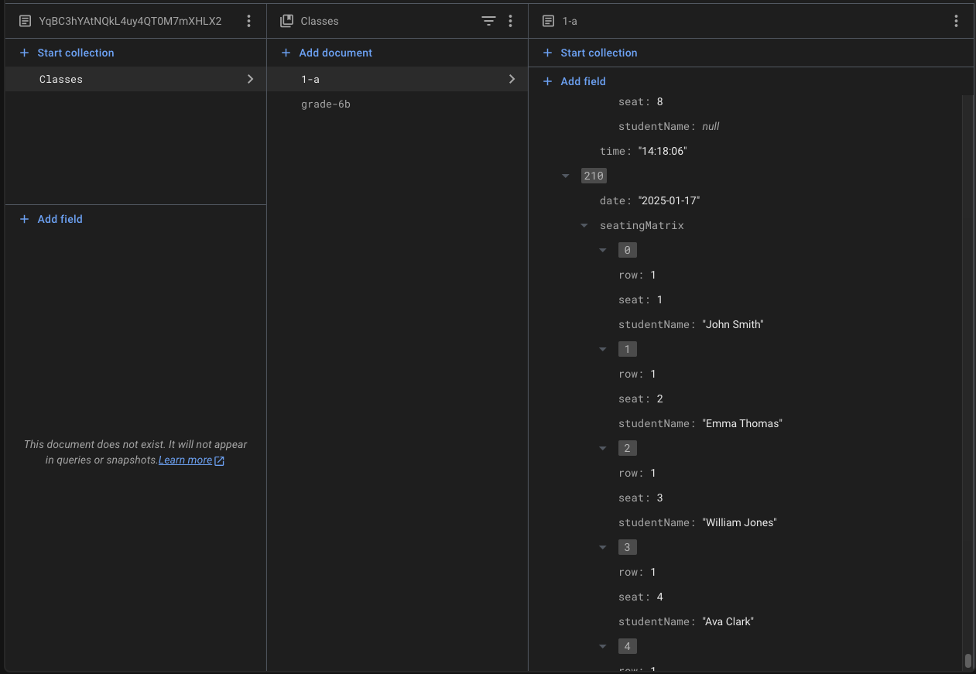

**7. Pre-Processing Logic**

Pre-processing in the Virtual Classroom project ensures that the data is clean, structured, and ready for processing. Below is an overview of the key pre-processing steps:

**7.1 Seating Arrangement Data**

* Inputs student constraints (e.g., seating preferences or special needs), and teacher-defined rules are validated.
* The **csp.js** algorithm uses these inputs to generate feasible seating plans by eliminating conflicts and optimizing for space and efficiency.

**7.2 Questionnaire Data**

* Questions created by teachers are formatted and validated to ensure compatibility with the Firebase database.
* Student responses are cleaned and pre-processed for consistency, enabling efficient storage and analytics.

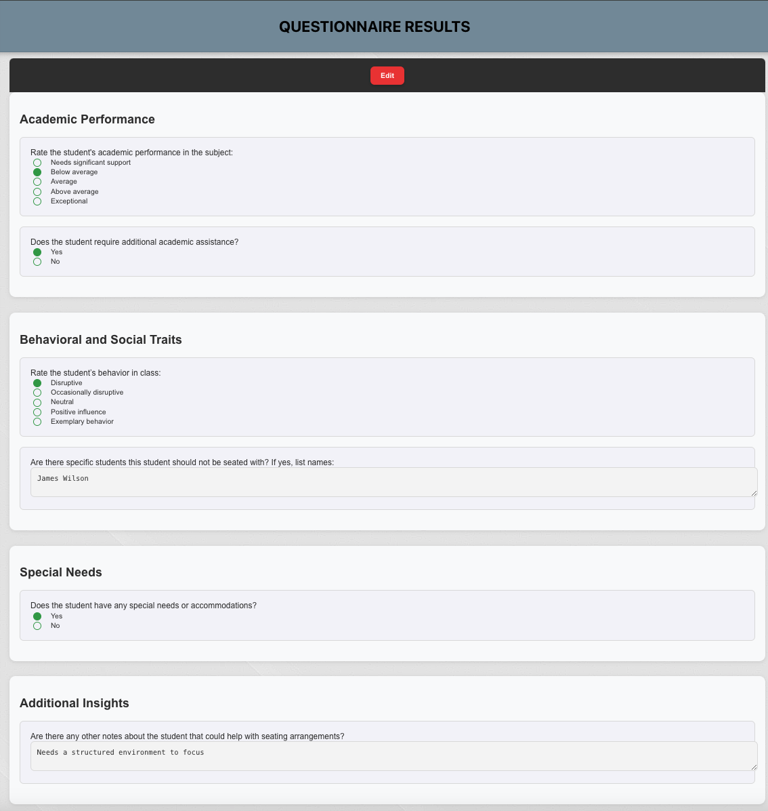

**7.3 User Data**

* Registration data (students and teachers) is validated for completeness (e.g., checking for duplicate entries or missing fields).
* Profile images, if uploaded, are compressed for efficient storage and faster retrieval.

By implementing these pre-processing steps, the system ensures smooth operations and minimizes errors during runtime.

**8. System Architecture**

The system architecture integrates a **frontend**, hosted on Vercel, for user interactions like managing students, generating seating arrangements, and collecting feedback. The **backend**, powered by Firebase Firestore and Cloud Functions, processes data and executes the CSP algorithm to optimize seating arrangements. A **user feedback loop** refines constraints based on teacher input, enhancing adaptability. Security is ensured through Firebase Authentication, environment variables, and HTTPS. Additionally, third-party APIs for emotional intelligence scoring and collaboration metrics further enhance system insights and functionality.

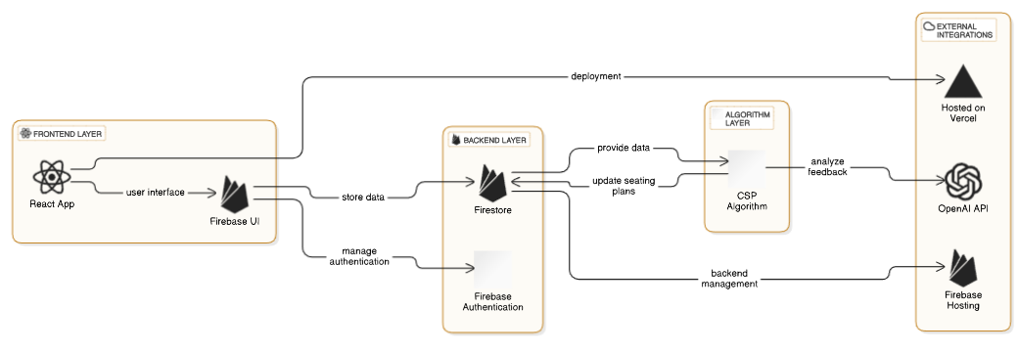

#### ****8.1 Package Diagram****

**Purpose:**  
The package diagram represents the overall system architecture by dividing it into logical layers or modules, showcasing their responsibilities and interdependencies.

**Key Elements:**

1. **Frontend Layer:**
   * Includes all user-facing components, such as the Login, Register, ShowStudents, MyClasses, Questionnaire, and GenerateSeating pages.
   * Contains CSS for styling and rendering the user interface.
   * Interacts with the backend to fetch and display data in real time.
2. **Backend Layer:**
   * Contains essential components for data processing and logic execution:
     + **Routing:** Manages API endpoints for communication between the frontend and backend.
     + **Middleware:** Handles user authentication and data validation.
     + **Models:** Defines data structures for Class, Student, and SeatingArrangement.
     + **Services:** Contains core logic for tasks such as running the **Seating Algorithm Module** and handling files.
   * Acts as a bridge between the frontend and database, ensuring secure and consistent data flow.
3. **Database Layer:**
   * Stores all relevant data, including:
     + Students, Teachers, and Classes.
     + Seating Arrangements and Environment Variables.
   * Allows real-time synchronization and scalability through a centralized data store.

**Connections:**

* **Frontend to Backend:** The frontend interacts with the backend through routing for user authentication, data retrieval, and algorithm execution.
* **Backend to Database:** The backend accesses and modifies the database for storing and retrieving information.
* **Internal Backend Dependencies:** The backend services utilize middleware, models, and other services to ensure a modular and efficient architecture.

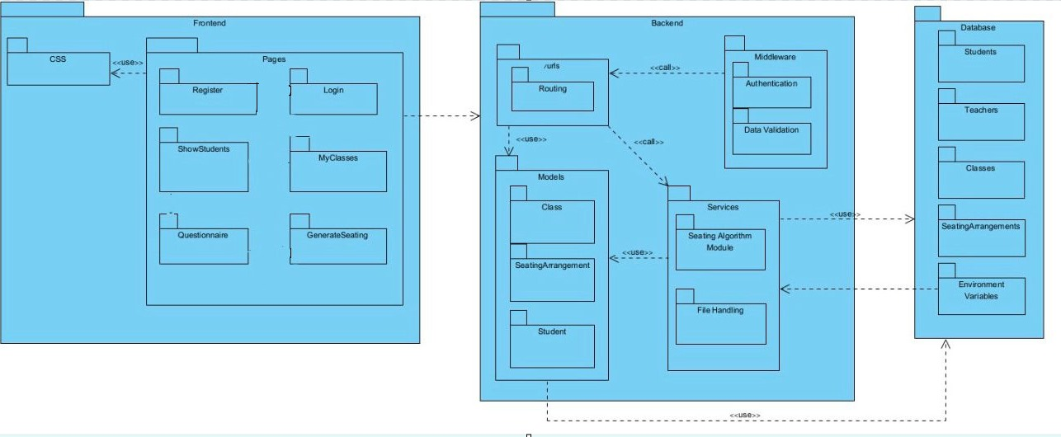

#### ****8.2 Activity Diagram****

* **Purpose**: Describes the sequential flow of activities in the system.
* **Key Workflows**:
  + **Seating Arrangement Generation**:
    - Users log in, provide constraints (e.g., class dimensions), and generate seating plans through the algorithm.
    - Results are reviewed, and feedback is provided.
  + **Questionnaire Workflow**:
    - Teachers create questionnaires, students submit responses, and the system collects data for analysis.
* **Decision Points**:
  + Includes conditional paths, like checking if the user is satisfied with the results or whether all questionnaires have been submitted.

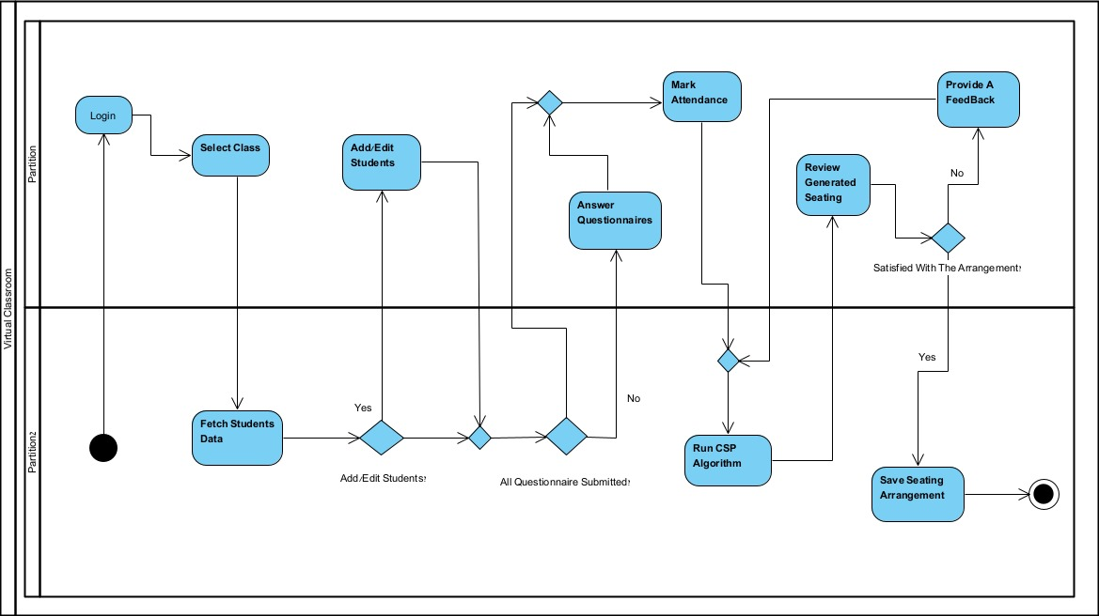

Teacher

System



#### ****8.3 Flow Diagram****

* **Purpose**: Shows the high-level process flow for user interactions with the system.
* **Key Elements**:
  + **Teacher Actions**: Logging in, selecting or creating classes, and adding/editing students.
  + **System Actions**: Fetching student data, running the csp.js algorithm, and storing the results.
  + **Feedback Loop**: Ensures teachers can provide feedback and refine results.

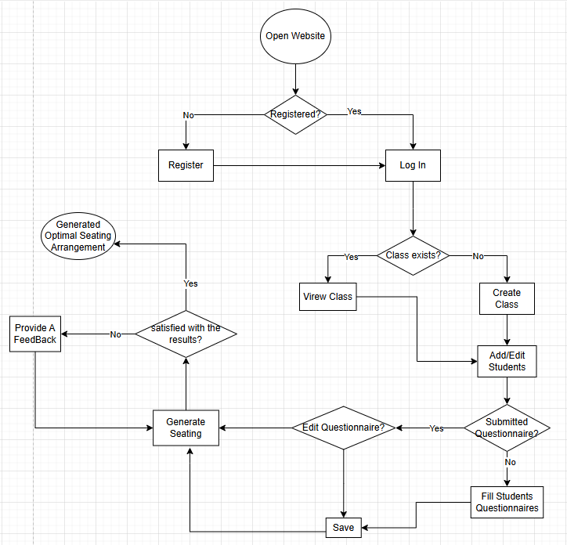

**9. Development Challenges**

During the development of the Virtual Classroom project, several challenges and obstacles were encountered, which shaped the final design and implementation. Key challenges include:

**9.1 Data Availability**

Ensuring real-time synchronization of data across multiple users posed a challenge. Firebase Firestore's real-time database features mitigated this but required careful management of data access rules to prevent conflicts.

**9.2 Working with a Virtual Environment**

Simulating a real classroom environment virtually required the design of flexible and intuitive interfaces. Testing dynamic features like seating arrangements and questionnaire handling required iterative feedback from test users.

**9.3 Deployment**

Deploying the project on Vercel demanded optimization for performance and compatibility. The integration of Firebase with Vercel also required configuring secure environment variables to maintain data privacy.

**9.4 Integration of Multiple Components**

The integration of React, Firebase, and the **csp.js** algorithm required managing asynchronous operations effectively. Debugging issues related to data flow between components was a significant effort.

**9.5 Obstacles in Design**

Designing a user interface that catered to diverse needs, such as seating arrangement flexibility and questionnaire customization, was a challenge. Balancing simplicity with advanced features like dark/light modes and analytics also required careful consideration.

**10. System Testing**

System testing ensures that all components of the Virtual Classroom project function as intended. Below are the key tests conducted:

**10.1 Functional Testing**

#### ****10.1.1 Login Functionality****

* **Test Case**: Attempt login with valid credentials.
  + **Expected Result**: User is logged in and redirected to the dashboard.
  + **Actual Result**: User successfully logged in and redirected to the dashboard.
* **Test Case**: Attempt login with invalid credentials.
  + **Expected Result**: An error message is displayed.
  + **Actual Result**: Error message "Invalid email or password" displayed correctly.
* **Test Case**: Attempt login with an empty email or password field.
  + **Expected Result**: Validation error prevents submission.
  + **Actual Result**: Form submission blocked, error message "Fields cannot be empty" displayed.

#### ****10.1.2 Adding Students****

* **Test Case**: Add more than 40 students to a class with a limit of 40.
  + **Expected Result**: The system prevents adding more students and displays an error message.
  + **Actual Result**: System displayed "The class has reached its maximum capacity of 40 students. Cannot add more students" and prevented additional students.

#### ****10.1.3 Questionnaire Validation****

* **Test Case**: Submit a questionnaire without answering the required fields.
  + **Expected Result**: The system displays a validation error and prevents submission.
  + **Actual Result**: Form submission blocked with a "Please fill out all required questions before submitting" error.

#### ****10.1.4 Seating Arrangement Tests****

The csp.js algorithm is a critical part of the system, and its functionality has been tested thoroughly using various edge cases:

* **Test Case 1**: Irregular classroom dimensions.
  + **Scenario**: A classroom with 3 rows and 5 columns.
  + **Expected Result**: The algorithm arranges students efficiently, ensuring no unseated students.
  + **Actual Result**: Algorithm successfully placed all students while maintaining constraints.
* **Test Case 2**: Behavior-based constraints.
  + **Scenario**: Two students with a behavior constraint (e.g., must not sit together).
  + **Actual Result**: Conflicting students were assigned different rows, maintaining separation.
  + **Expected Result**: The algorithm places the students in separate rows or distant seats.
* **Test Case 3**: Absent students.
  + **Scenario**: Marking 5 out of 25 students as absent before generating seating.
  + **Expected Result**: The absent students are excluded from the seating arrangement.
  + **Actual Result**: All absent students were correctly omitted from the final seating.
* **Test Case 4**: Classroom with uneven distribution of students per row.
  + **Scenario**: A classroom of 20 students in a room with 5 rows and 4 columns.
  + **Expected Result**: The algorithm distributes students evenly while ensuring no seat is left unnecessarily empty.
  + **Actual Result**: Students were evenly placed, and empty seats were minimized effectively.
* **Test Case 5**: Repeated generation with modified constraints.
  + **Scenario**: Generating seating for the same classroom multiple times with different constraints.
  + **Expected Result**: Each generation respects the new constraints without errors or overlap.
  + **Actual Result**: The algorithm adapted to constraint changes and successfully generated different valid arrangements.

#### ****10.1.5 Other Tests****

* **Test Case**: Dark/Light mode toggle.
  + **Expected Result**: The system toggles between modes without affecting functionality.
  + **Actual Result**: Dark and light modes switched successfully without UI issues.
* **Test Case**: Real-time data updates (e.g., adding students or updating questionnaires).
  + **Expected Result**: Updates are reflected across all users in real time.
  + **Actual Result**: Changes were instantly visible across devices, confirming real-time updates.

**10.2 Acceptance Testing**

Beyond functional testing, we conducted a series of acceptance tests to confirm that the system met the predefined requirements. These tests included:

* **Correct Data Processing**: The system processed all inputs accurately and executed operations seamlessly. Login functionality was validated to ensure users were correctly authenticated and redirected to the appropriate page. Additionally, real-time updates such as adding students and updating questionnaires were successfully reflected across all users, ensuring data consistency and reliability over multiple test runs.
* **Error Handling**: All edge cases were meticulously tested to verify that the system displayed user-friendly error messages whenever errors occurred. For example, attempts to add more than 40 students to a class or submit a questionnaire with missing fields resulted in clear notifications to users. In seating arrangement generation, invalid inputs or constraints triggered appropriate error messages, and users were redirected to the home page shortly after, maintaining system usability and stability.
* **Accuracy Validation**: The csp.js algorithm was thoroughly tested to ensure it generated valid seating arrangements for diverse scenarios, including irregular classroom dimensions, behavior-based constraints, and absent students. The system consistently met expectations by respecting constraints and distributing students efficiently. Repeated runs with modified constraints confirmed that the algorithm-maintained accuracy and adaptability under varying conditions.

**11. Experiment and Evaluation**

The Virtual Classroom project was rigorously tested to ensure functionality, performance, and user satisfaction. The evaluation involved simulated classroom scenarios, real user testing, and performance analysis.

**11.1 Experiment**

* The system was tested in simulated classroom scenarios where teachers created seating arrangements, distributed questionnaires, and analyzed responses.
* Multiple input cases were evaluated for the **csp.js** algorithm, including varying classroom sizes and seating constraints, to test its flexibility and robustness.
* User interactions were simulated to validate session management, data synchronization, and UI responsiveness across devices.

The system was tested by:  
 **Developer friends** who assessed functionality and performance.  
 **Teachers from our families** who evaluated usability, seating effectiveness, and overall user experience.

**11.2 Verification and Evaluation**

* **Functional Testing**: Each feature, including seating arrangements, registration, and questionnaire handling, was tested individually to ensure correct functionality.
* **Acceptance Testing**: End users reviewed the system and provided feedback. Adjustments were made to improve user experience based on their suggestions.
* **Performance Evaluation**: Real-time data synchronization and algorithm execution times were measured to ensure smooth operations.

**11.3 Results**

The evaluation confirmed that the Virtual Classroom project met its objectives. The key results include:

* The **csp.js** algorithm successfully generated optimized seating plans.
* User interactions were intuitive, and data synchronization was seamless across devices.
* Dark/light themes and session management features enhanced usability and accessibility.
* Deployment on Vercel ensured stable and efficient system performance.

**References:**

[1]Darling-Hammond, L., & Cook-Harvey, C. M. (2018). Educating the whole child: Improving school climate to support student success. Learning Policy Institute.

[2]Tomlinson, C. A. (2001). How to differentiate instruction in mixed-ability classrooms. ASCD.

[3] Barkley, R. A. (2016). Attention-deficit hyperactivity disorder: A handbook for diagnosis and treatment (4th ed.). Guilford Press.

[4] Weinstein, C. S. (1979). The physical environment of the school: A review of the research. Review of Educational Research, 49(4), 577-610.

[5] Wikipedia contributors. (2023, August 25). *Constraint satisfaction problem*. Wikipedia, The Free Encyclopedia.

[6] Wannarka, R., & Ruhl, K. (2008). Seating arrangements that promote positive academic and behavioural outcomes: A review of empirical research. Support for Learning, 23(2), 89-93.

[7] Cohen, E. G. (1994). Restructuring the classroom: Conditions for productive small groups. *Review of Educational Research*, 64(1), 1-35.

[8] Weinstein, C. S. (2004). Classroom Design as an External Condition for Learning. Educational Psychologist, 39(3), 147-163.

[9] Rosenfield, P., Lambert, N. M., & Black, A. (1985). Desk arrangement effects on pupil classroom behavior. Journal of Educational Psychology,

[10] Salend, S. J., & Garrick Duhaney, L. M. (1999). The Impact of Inclusion on Students With and Without Disabilities and Their Educators. Remedial and Special Education, 20(2), 114-126.

[11] Dillenbourg, P., & Evans, M. (2011). Interactive tabletops in education. International Journal of Computer-Supported Collaborative Learning, 6(4), 491-514.

[12] <https://miscellaneousme.wordpress.com/2011/09/01/smart-seat-the-seating-chart-app/>

[13] https://www.classcharts.com/

[14] <https://www.classdojo.com/>

[15] "The SEL Solution: Integrate Social-Emotional Learning into Your Curriculum and Build a Caring Climate for All" by Jonathan C. Erwin, M.A.



Software Engineering Department  
Braude College

Capstone Project Phase B – 61999

**Adaptive Student Arrangement System for Enhanced Learning**

**User Guide**

Advisor: Natali Levi

Students: Nabi Mari

Yoda Amer

Table Of Contents

**Table of Contents ............................................................................ 35  
Introduction ..................................................................................... 36  
Sidebar ............................................................................................. 36  
1 Home Page .................................................................................... 37**    1.1 Not-Logged In Home Page ..................................................... 37  
    1.2 Logged In Home Page ............................................................ 39 **2 Login Page .................................................................................... 41  
3 Register Page ................................................................................ 43  
4 My Classes Page ........................................................................... 45  
5 Student Management Page ......................................................... 47  
6 Show Students for Questionnaire Page ...................................... 49  
7 Questionnaire Page ...................................................................... 51  
8 Questionnaire Results Page ........................................................ 53  
9 Analytics Page .............................................................................. 55  
10 Seating Arrangement Page ....................................................... 57**

Introduction:

The Classroom Seating Arrangement System helps teachers create optimal seating plans by analyzing student data, including academic performance, behavior, language, and special needs. Using a CSP algorithm, it generates arrangements that promote effective learning while addressing individual and group needs. Teachers can manage student profiles, review seating plans, and save customized arrangements, streamlining classroom organization and fostering a supportive learning environment.

Sidebar:



The **Sidebar** acts as a primary navigation tool for teachers. It provides quick access to essential sections, including:

* **Home**: Returns the user to the main dashboard.
* **My Classes**: Allows teachers to manage and view their classes.
* **Questionnaire**: Enables access to student questionnaires.
* **Analytics**: Displays performance and behavior insights.
* **Seating Arrangement**: Facilitates the generation and review of classroom seating plans.
* **Logout**: Securely logs the user out of the system.

The sidebar also includes a dark mode toggle for a customized interface experience.

1-Home Page:

1.1-Not-Logged In Home Page:

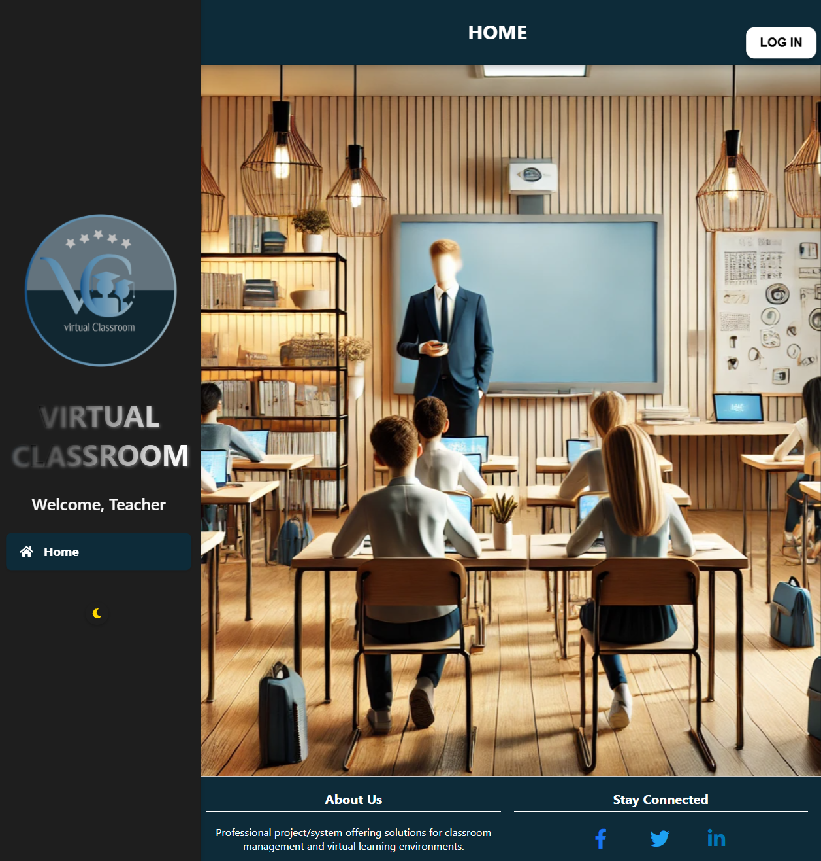

The **Not-Logged in Home Page** serves as the central hub for teachers, featuring a navigation bar for accessing key functionalities, a personalized welcome message, and a classroom-themed design. It includes a login button, theme toggle, and quick links to resources like "About Us" and social media (**not really has a link to a relative pages**), ensuring easy navigation and an engaging user experience.

1.1-In Light Mode

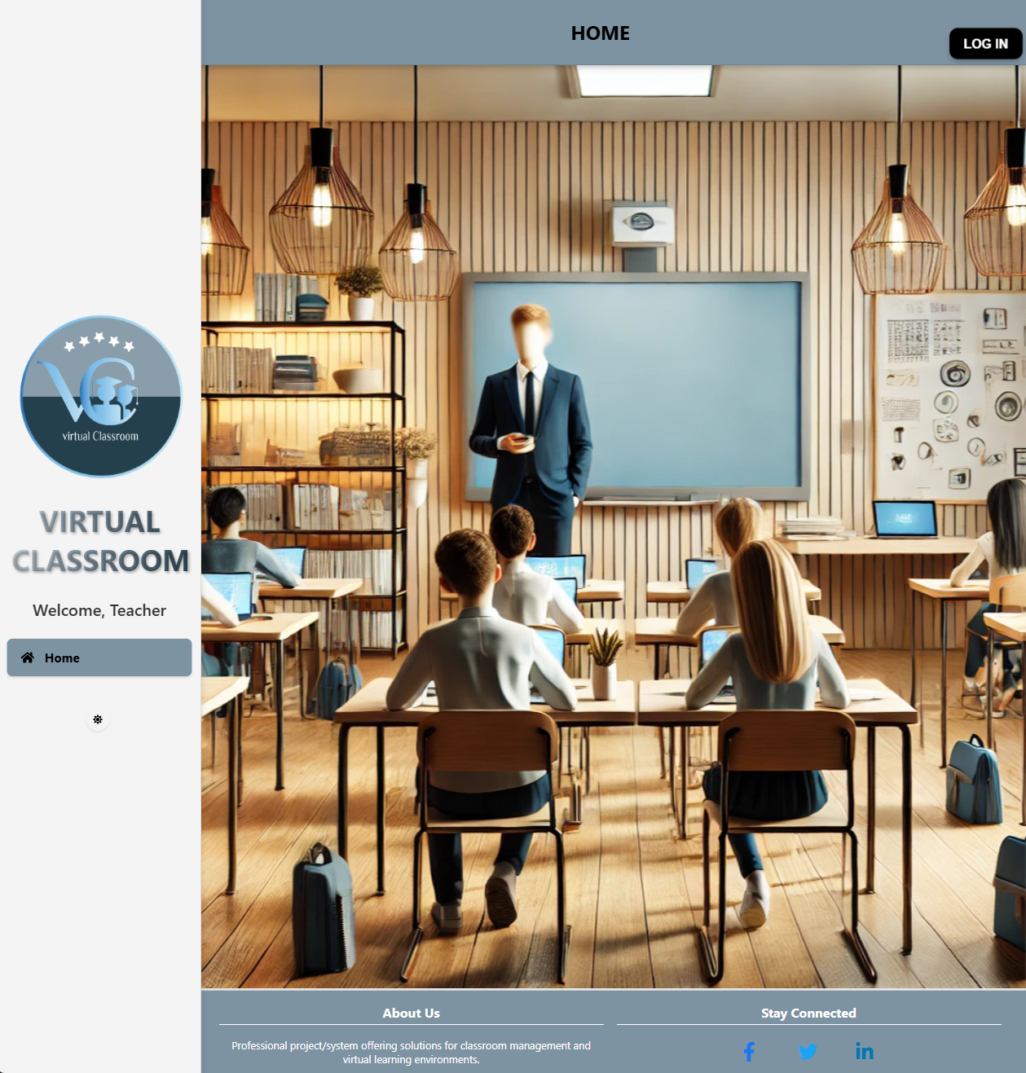

1.2-Logged in Home Page:

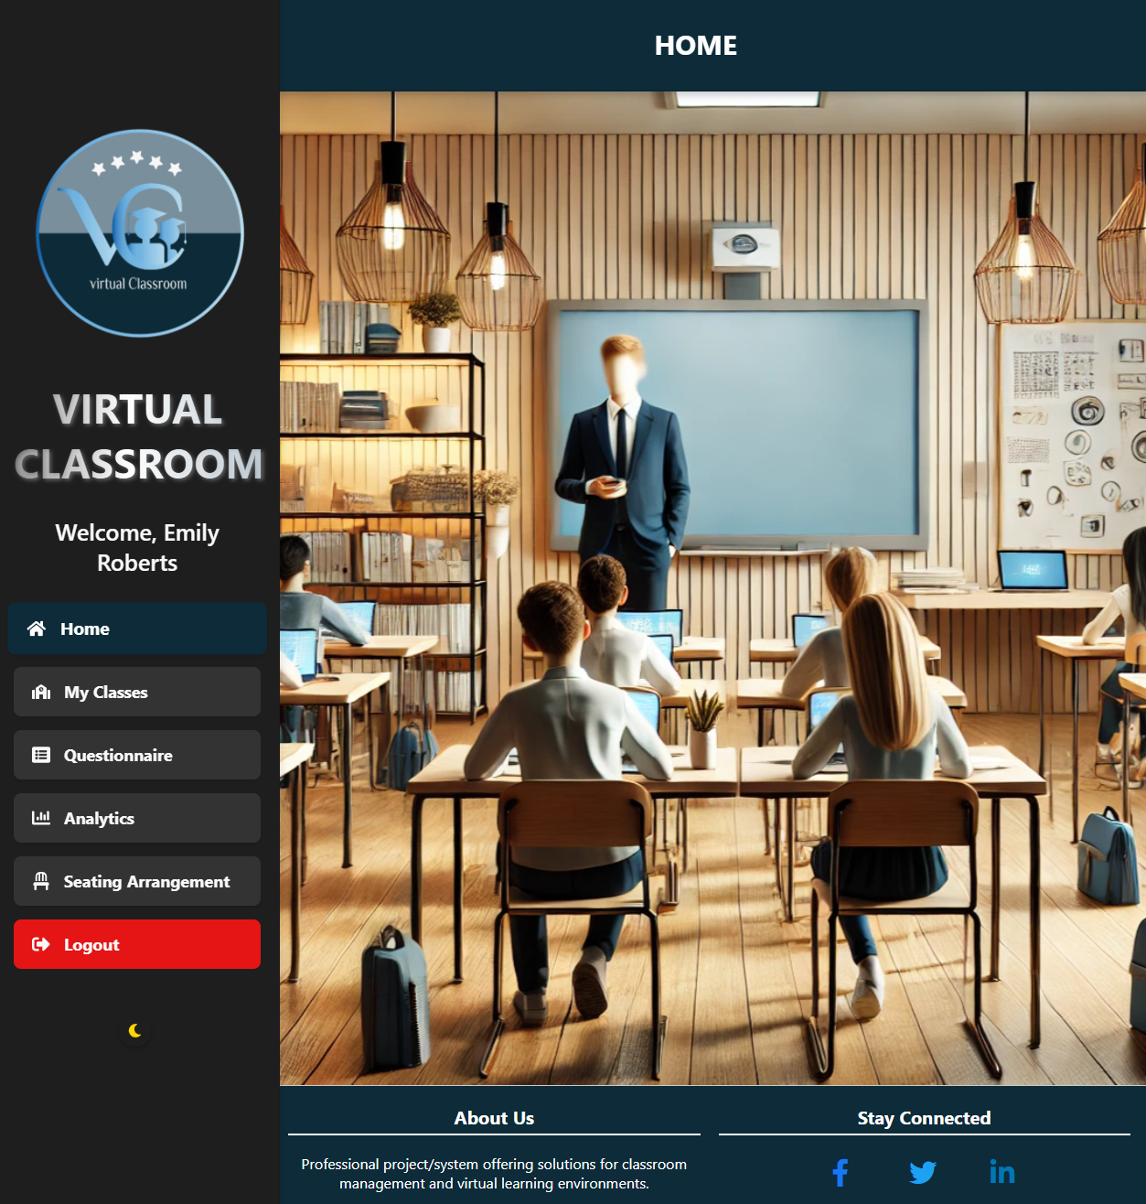

The **Logged-In Home Page** welcomes the teacher with a personalized greeting and provides a user-friendly navigation menu. It includes options for managing classes, accessing questionnaires, viewing analytics, and generating seating arrangements. The layout ensures easy access to all key functionalities, empowering teachers to efficiently manage their virtual classrooms.

1.2-In Light Mode

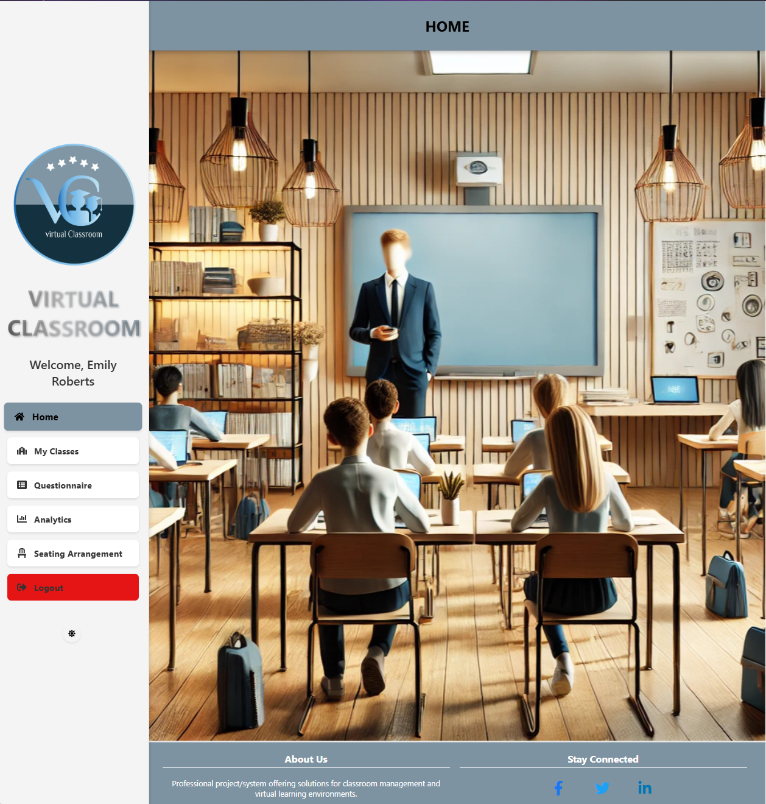

2-Login Page:

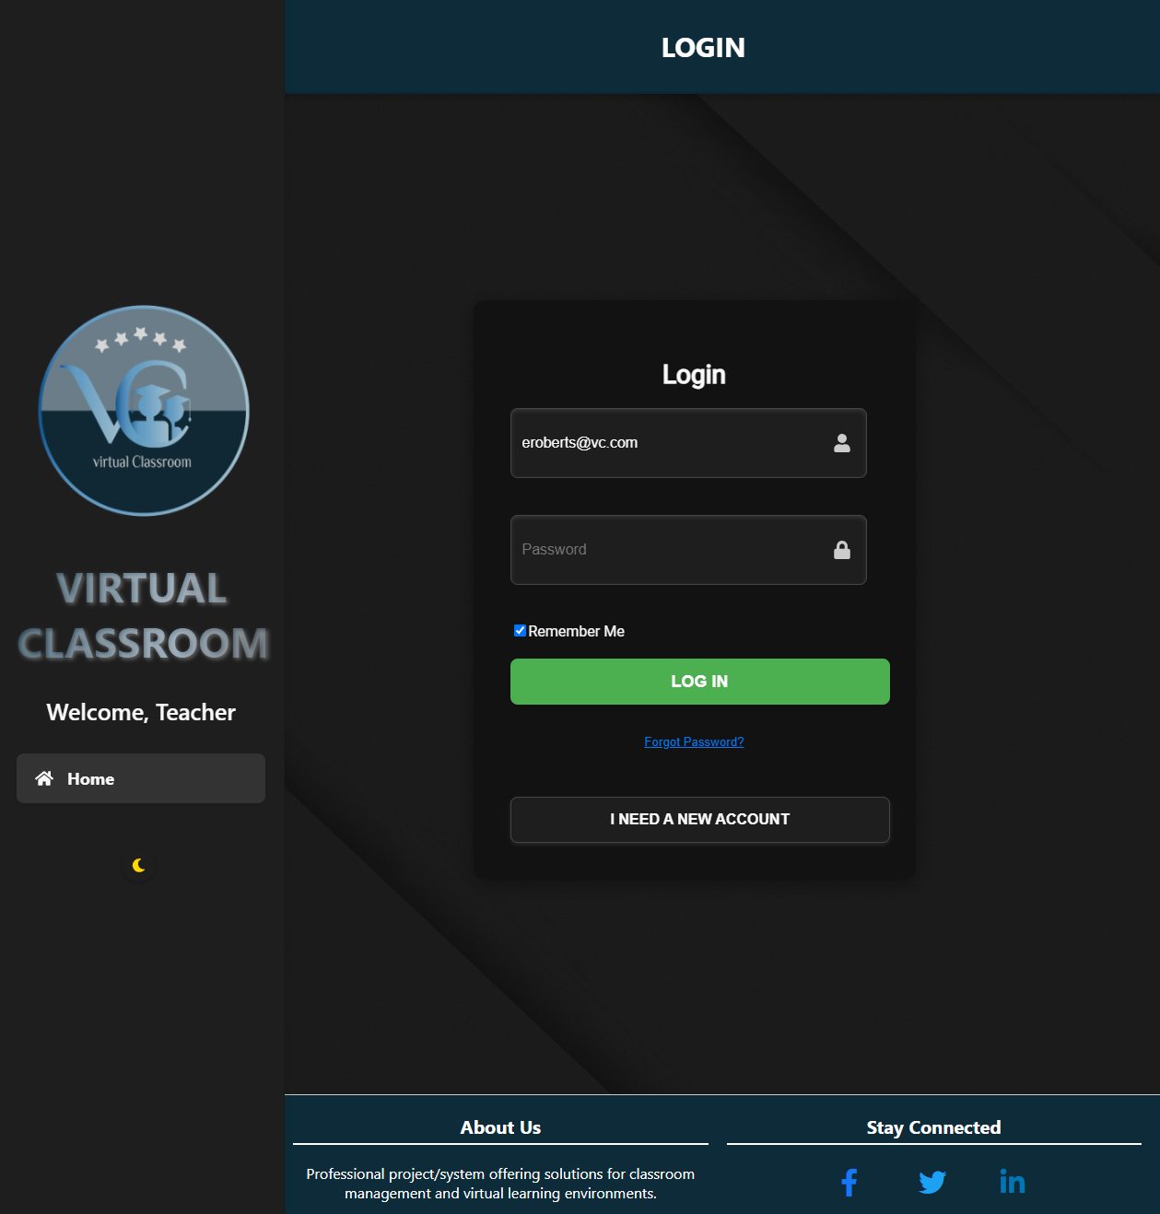

The **Login Page** provides a secure and user-friendly interface for teachers to access the system. It includes fields for email and password, a "Remember Me" checkbox, options for password recovery, and account creation. The clean design ensures a seamless and intuitive login process for users.

2-In Light Mode

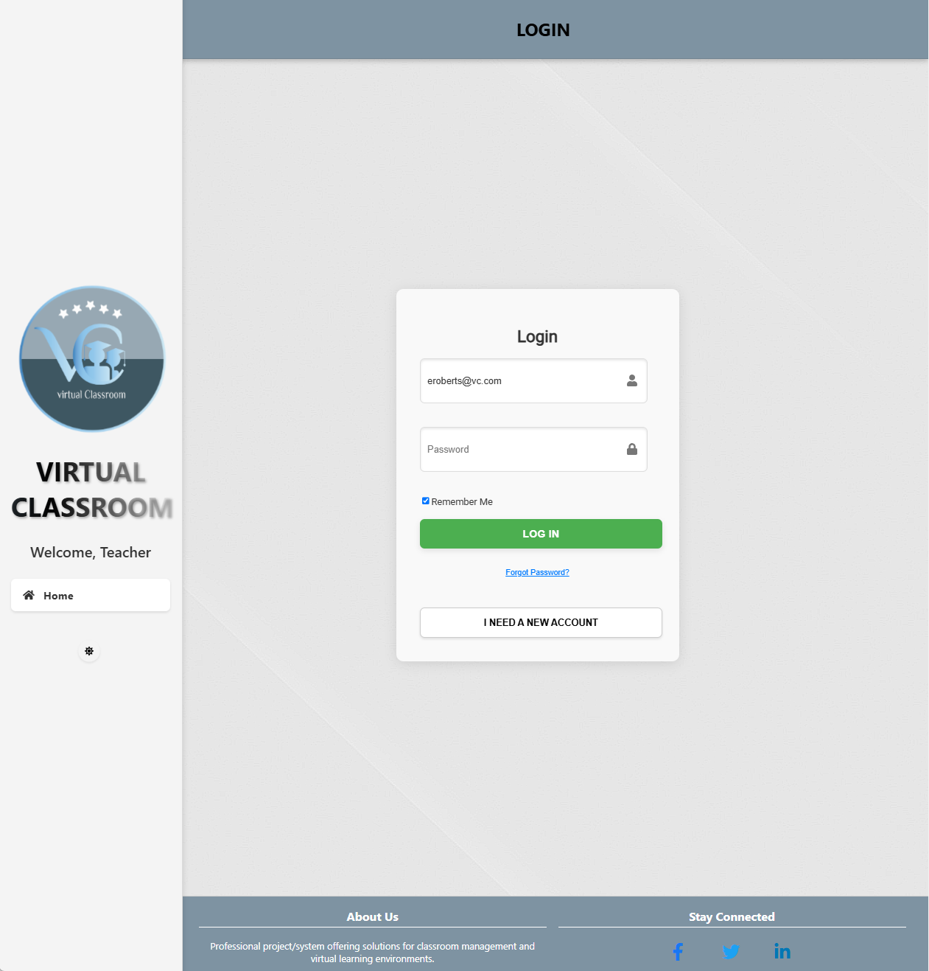

3-Register Page:

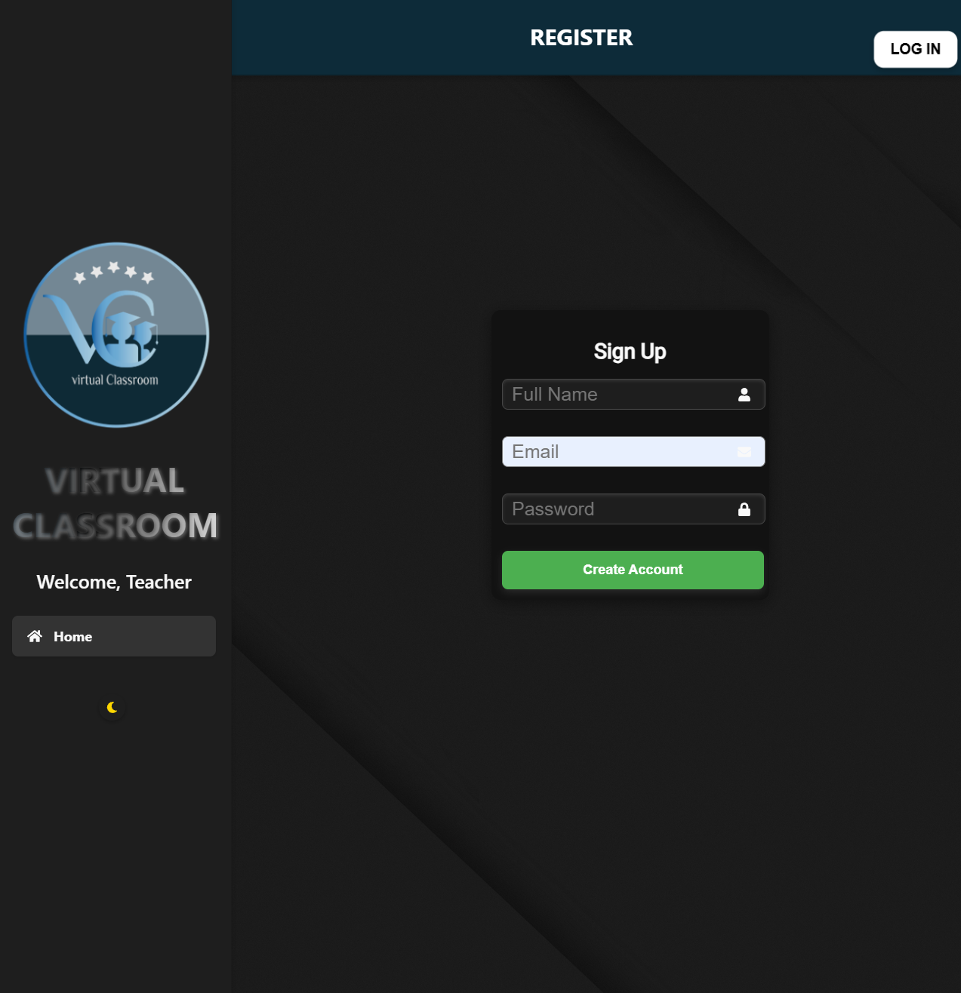

The **Register Page** allows new users to create an account by providing their full name, email, and a secure password. The straightforward design ensures an easy and efficient registration process, enabling teachers to quickly access the platform's features.

3-In Light Mode

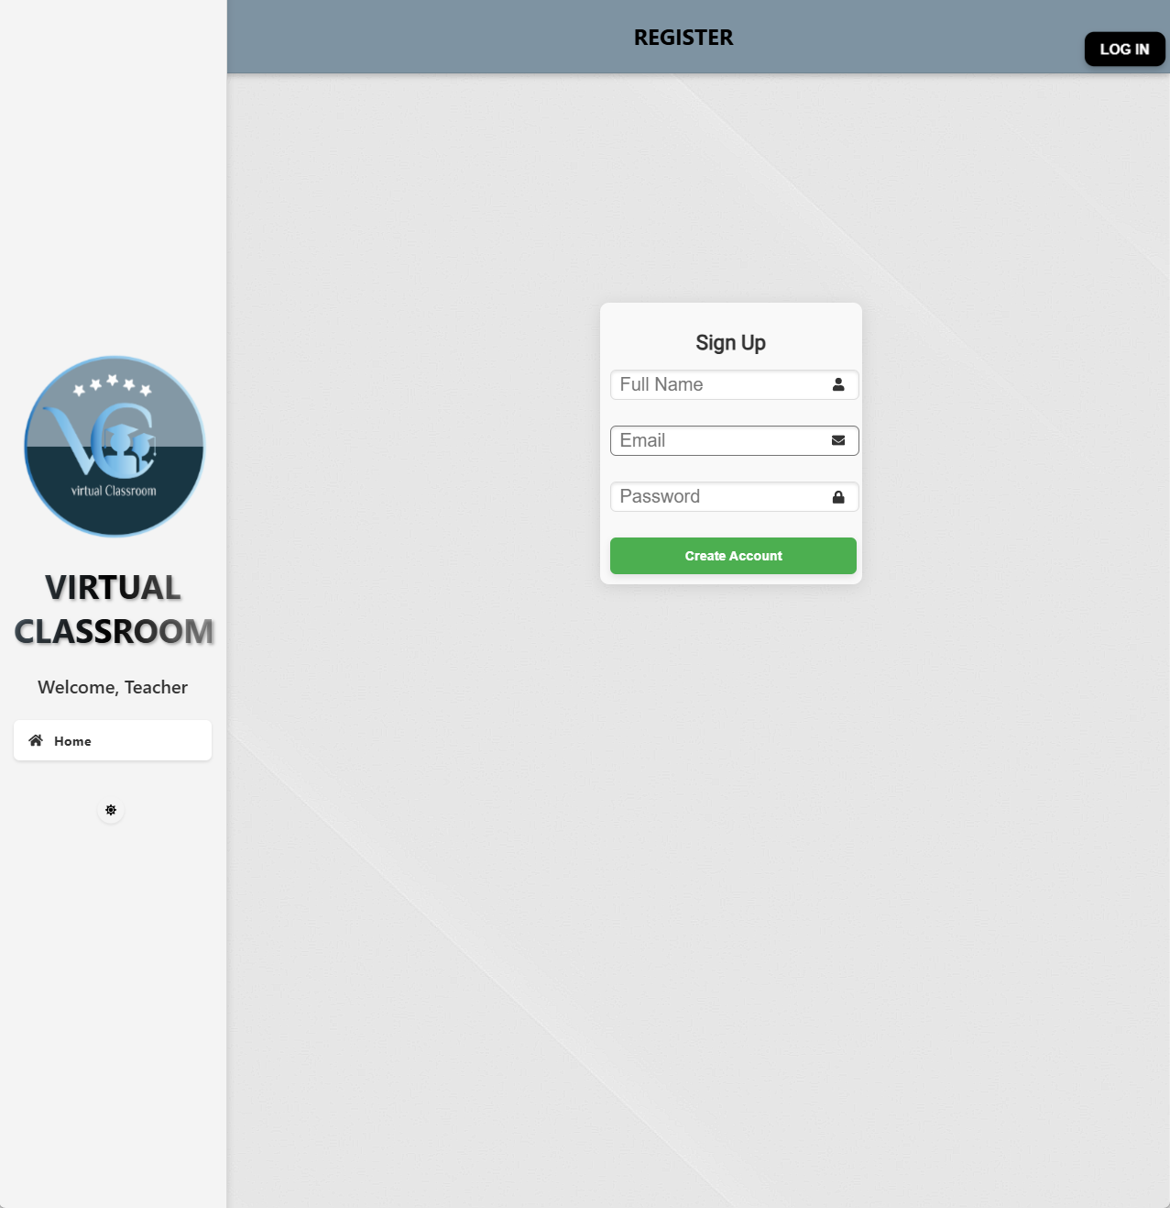

4- My Classes Page:

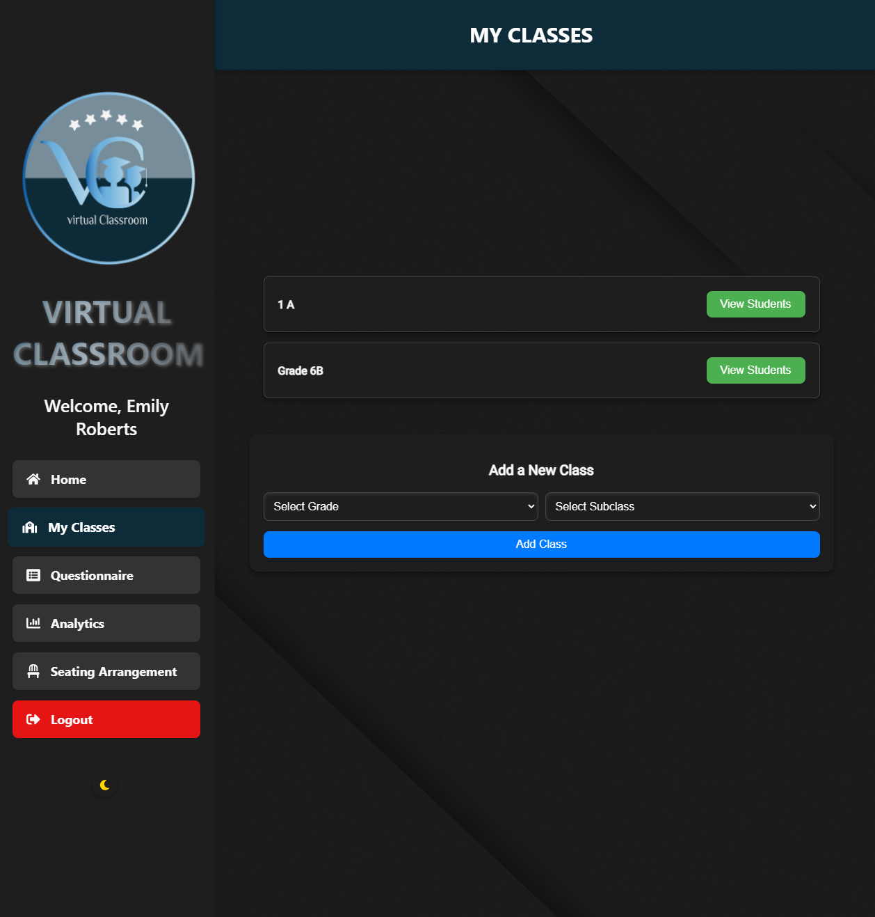

The **My Classes** page provides teachers with a streamlined interface to manage their classes. Teachers can view their existing classes, represented as a list, and navigate to student details for each class. Additionally, the page allows the teacher to add new classes by selecting the grade and subclass from dropdown menus. The interface ensures clarity and functionality by providing buttons for each class to view associated students and a dedicated section to add new classes.

4-In Light Mode

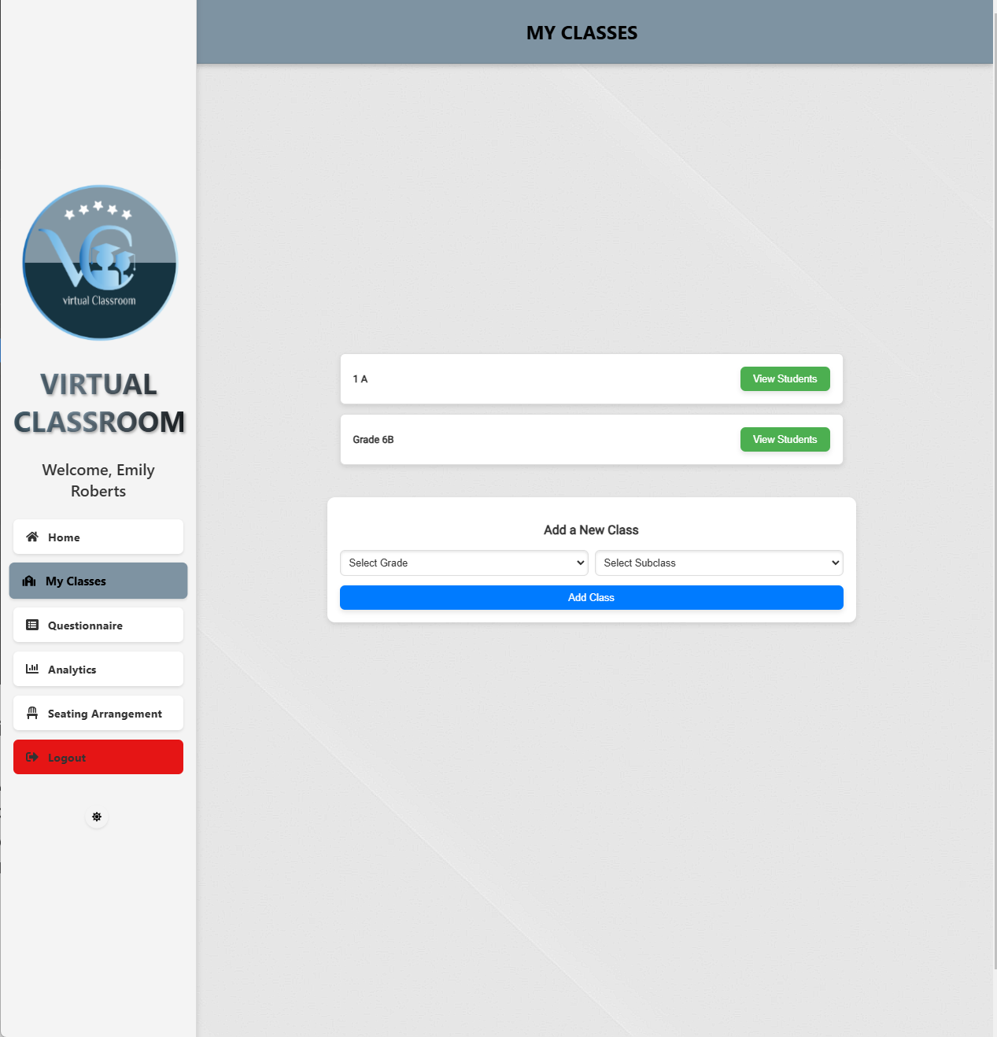

5-Student Management Page:

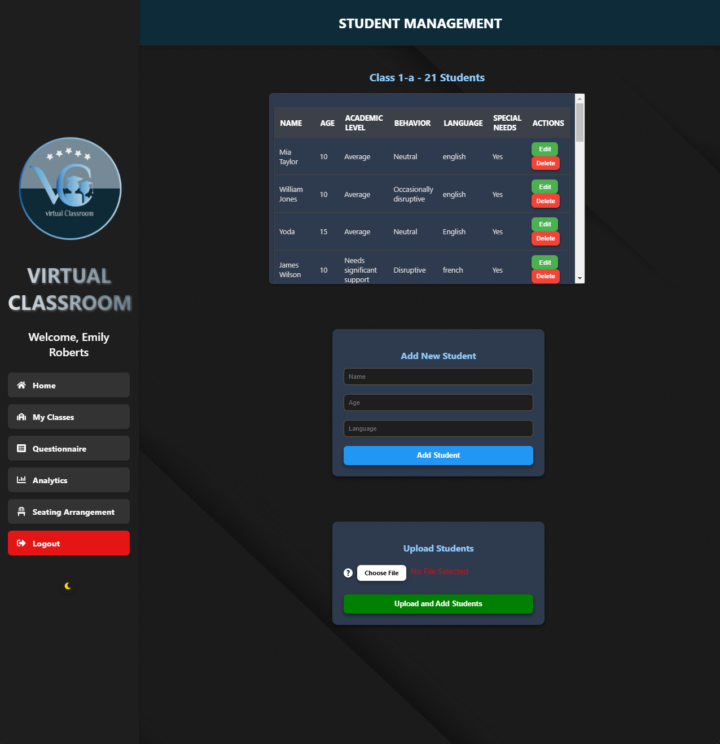

The **Student Management Page** allows teachers to manage students in a selected class. It displays a table with each student’s name, age, academic level, behavior, language, and special needs, along with options to edit or delete details. Teachers can add new students manually by entering their name, age, and language (other details are provided via the questionnaire), with constraints like a 40-student limit and an age cap of 18 years.

Teachers can also upload student data in bulk via .csv or .xlsx files containing Name, Age, and Language columns. Clear instructions and a tooltip guide teachers on the file format for seamless bulk management.

5-In Light Mode

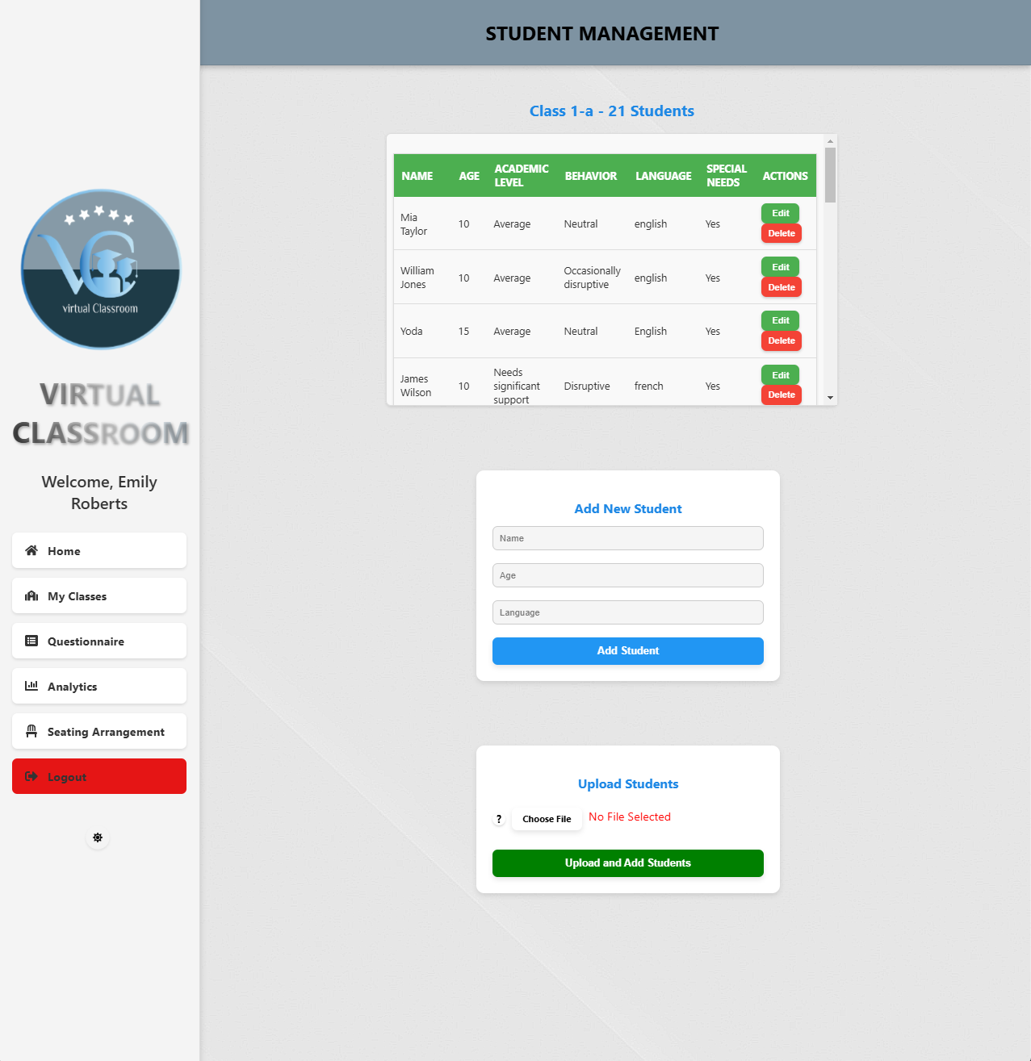

6-Show Students For Questionnaire Page:

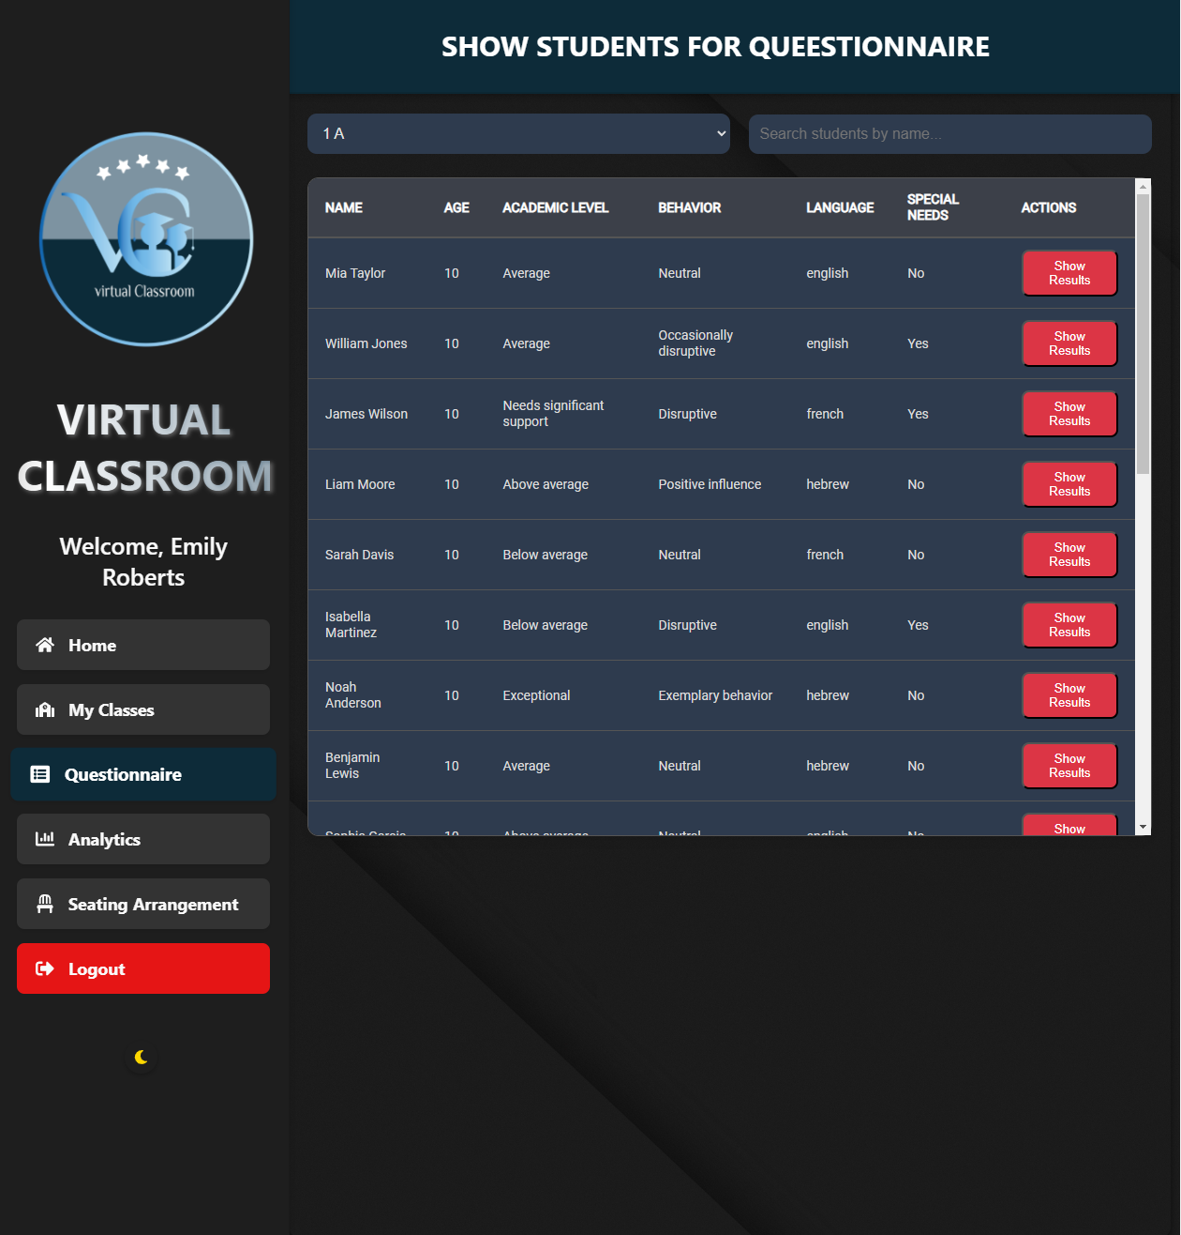

The **show students for questionnaire page** is designed to display students in the selected class and provides functionality to manage questionnaires. Teachers can choose a class from the dropdown menu, fetch the list of students, and search for specific names using the search bar. Each student is displayed with their details like name, age, academic level, behavior, language, and whether they have special needs. For students without a submitted questionnaire, a "Do Questionnaire" button is available, directing the teacher to the questionnaire page. For students with submitted responses, a "Show Results" button allows the teacher to review and edit their data. The interface is user-friendly, ensuring seamless management of class-specific questionnaires and student information.

6-In Light Mode

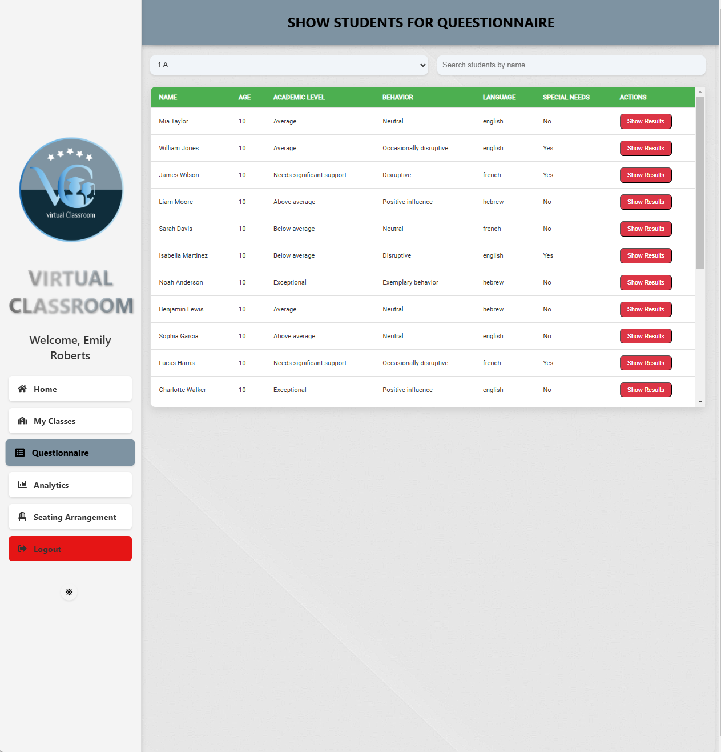

7-Questionnaire Page:

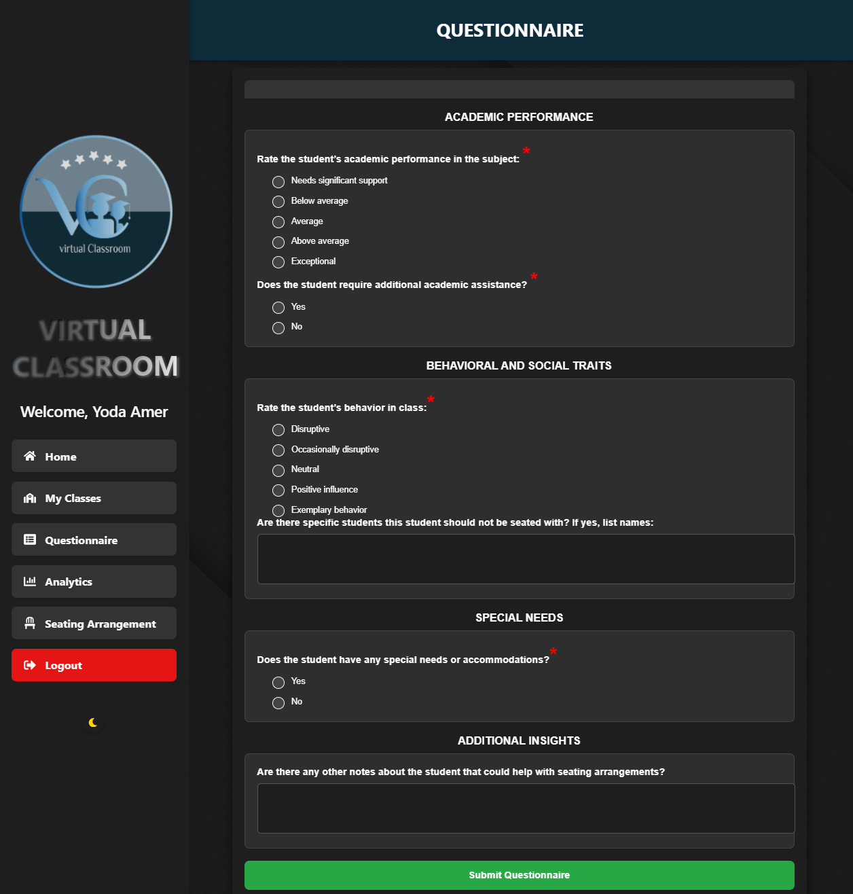

The **Questionnaire Page** serves as a detailed interface for teachers to evaluate and input data about students, ensuring an optimal classroom seating arrangement. It categorizes inputs into four main sections: Academic Performance, Behavioral and Social Traits, Special Needs, and Additional Insights. Each section includes mandatory questions denoted by a red asterisk, ensuring complete responses. Teachers can assess academic performance, behavior, and special needs, while also providing specific notes or preferences, such as students to avoid seating together. After completing the form, teachers submit the data for integration into the system's seating algorithm, supporting personalized classroom management.

7-In Light Mode

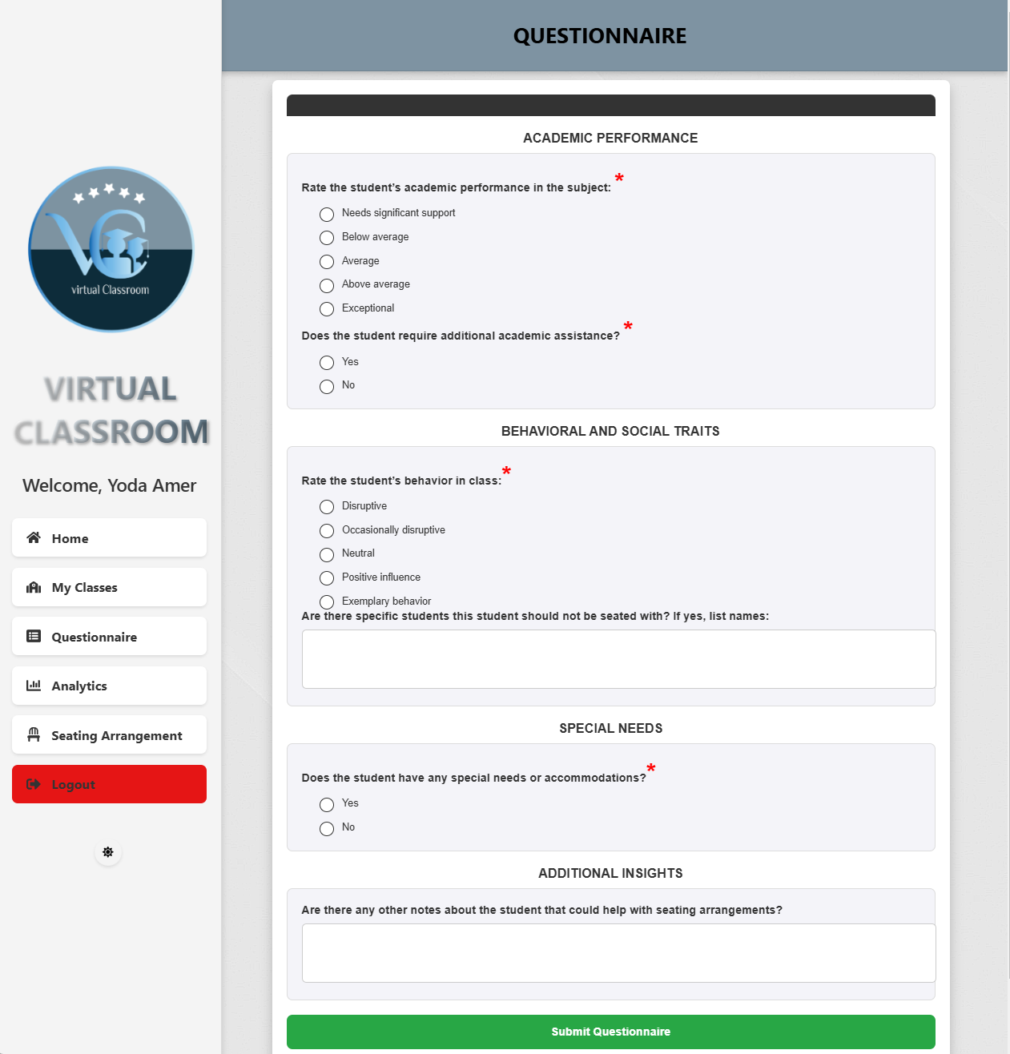

8-Questionnaire Results Page:

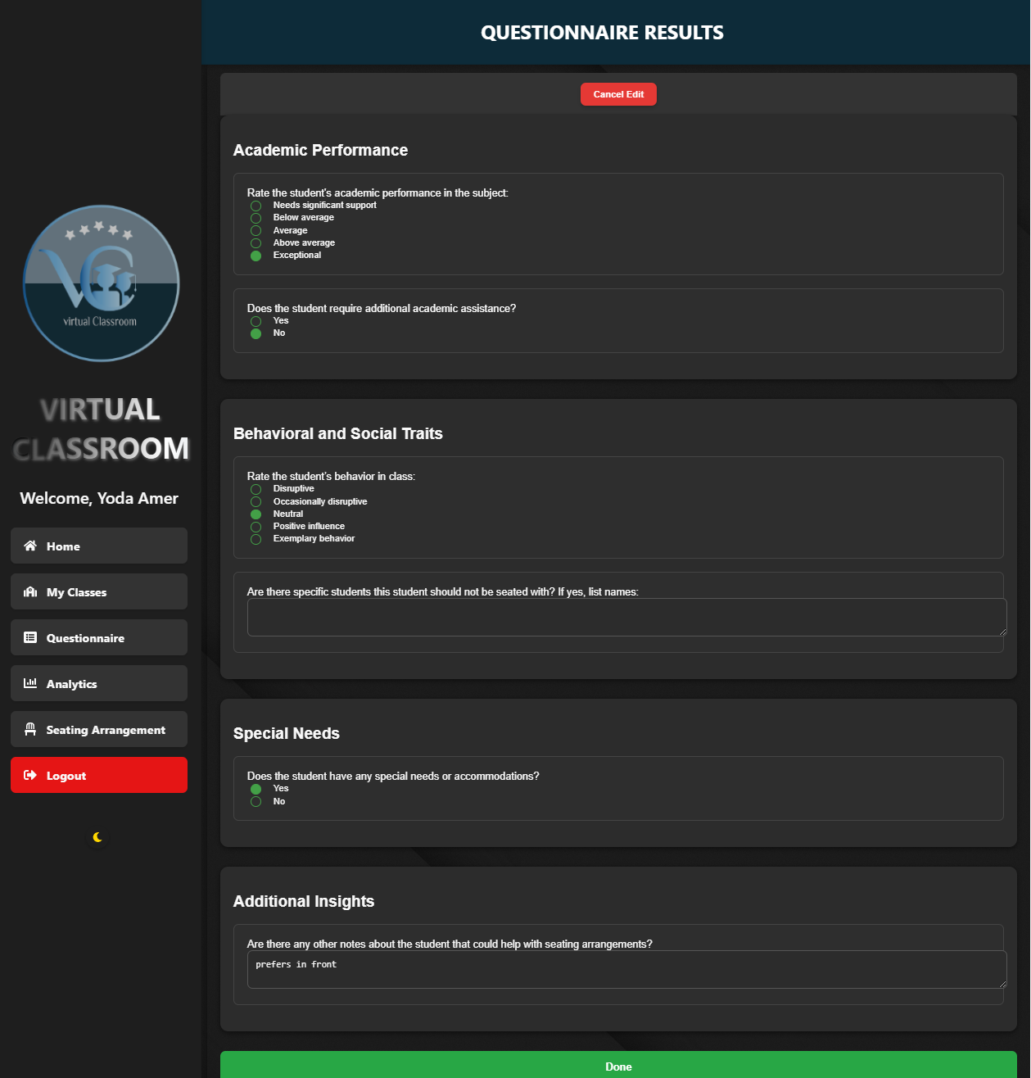

The **Questionnaire Results Page** displays a detailed summary of the responses submitted for each student's questionnaire. Teachers can view categorized sections such as Academic Performance, Behavioral and Social Traits, Special Needs, and Additional Insights. Each category includes the relevant questions and answers. Teachers can toggle between view and edit modes. In edit mode, users can modify the responses and save the changes using the "Done" button. The interface ensures clear visibility of the student's data while maintaining a user-friendly design.

8-In Light Mode

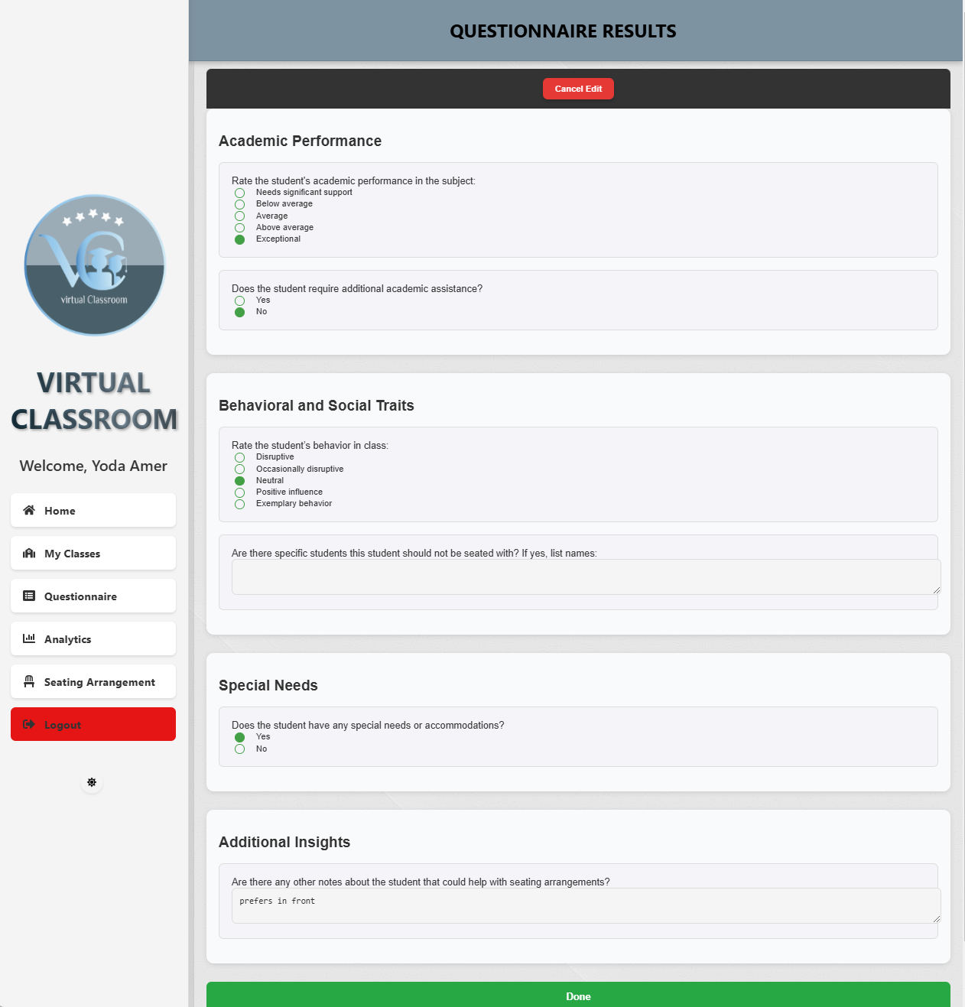

9-Analytics Page:

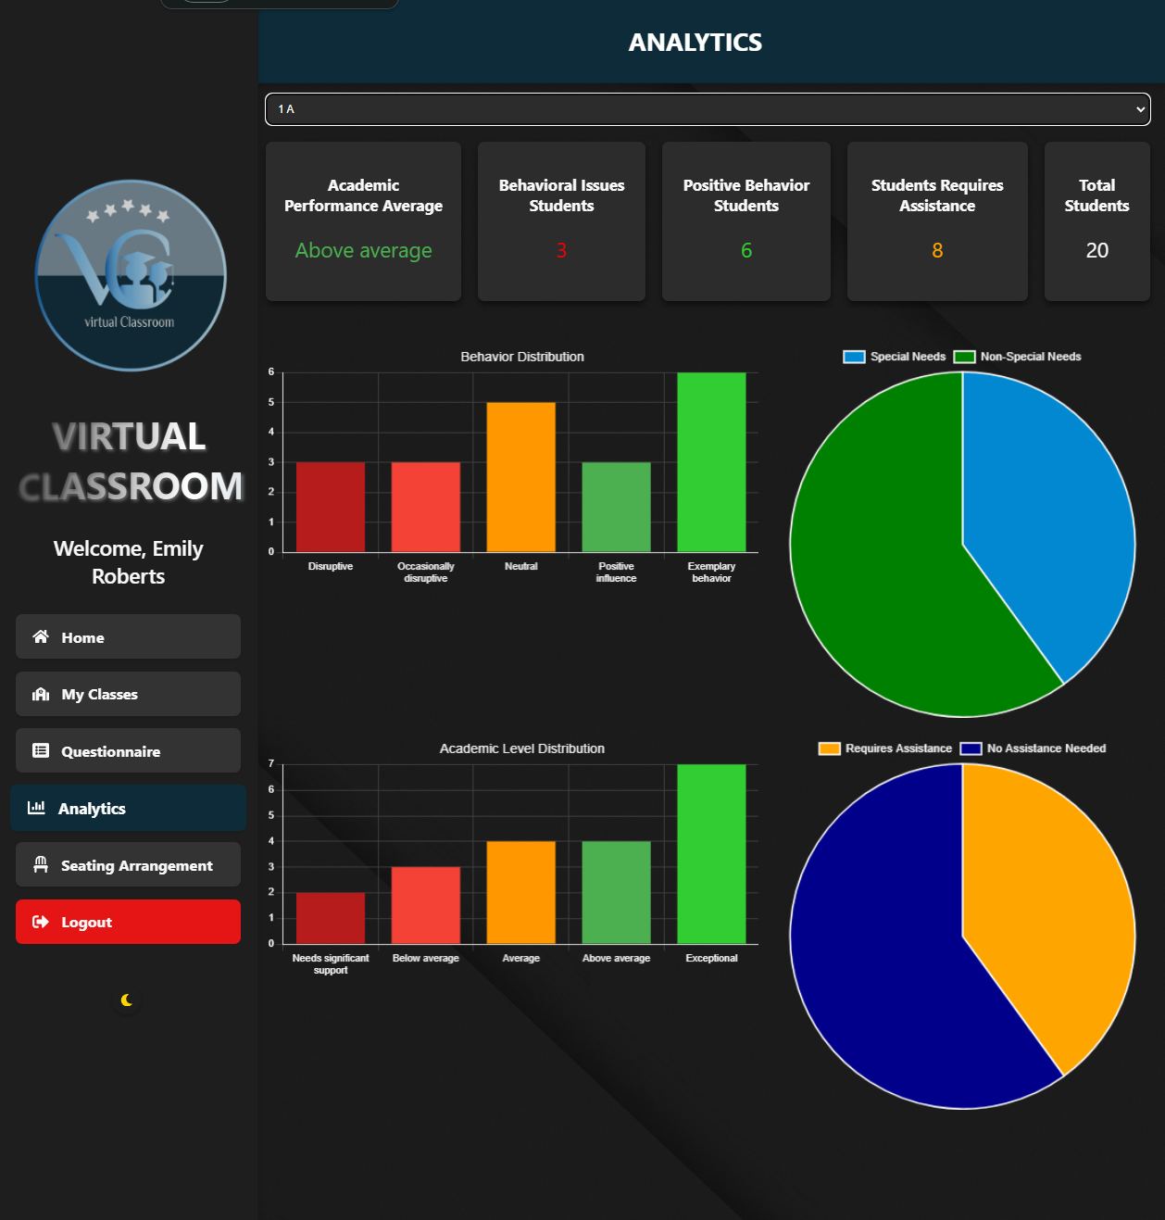

The **Analytics** page provides a comprehensive analysis of a class's performance and behavioral data. Teachers can select a specific class to view detailed analytics, including average academic performance, behavioral issues, positive behavior statistics, students requiring assistance, and the total number of students. The data is visually represented using bar charts for behavior and academic level distributions and pie charts for special needs and assistance requirements. These visualizations allow teachers to understand their class composition and dynamics effectively.

9-In Light Mode

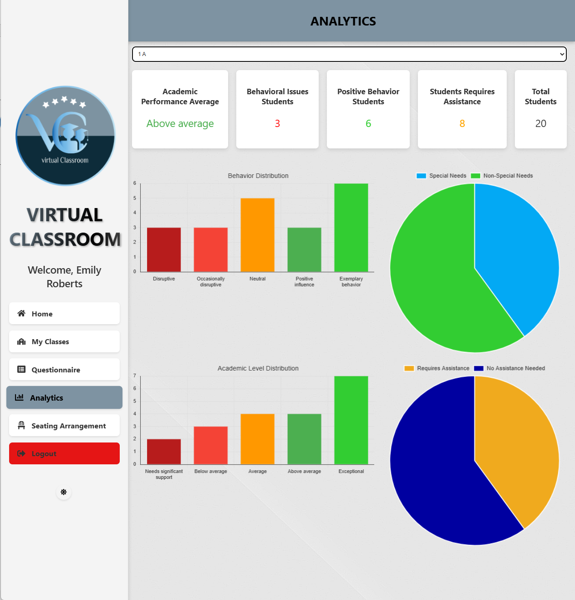

10-Seating Arrangement Page:

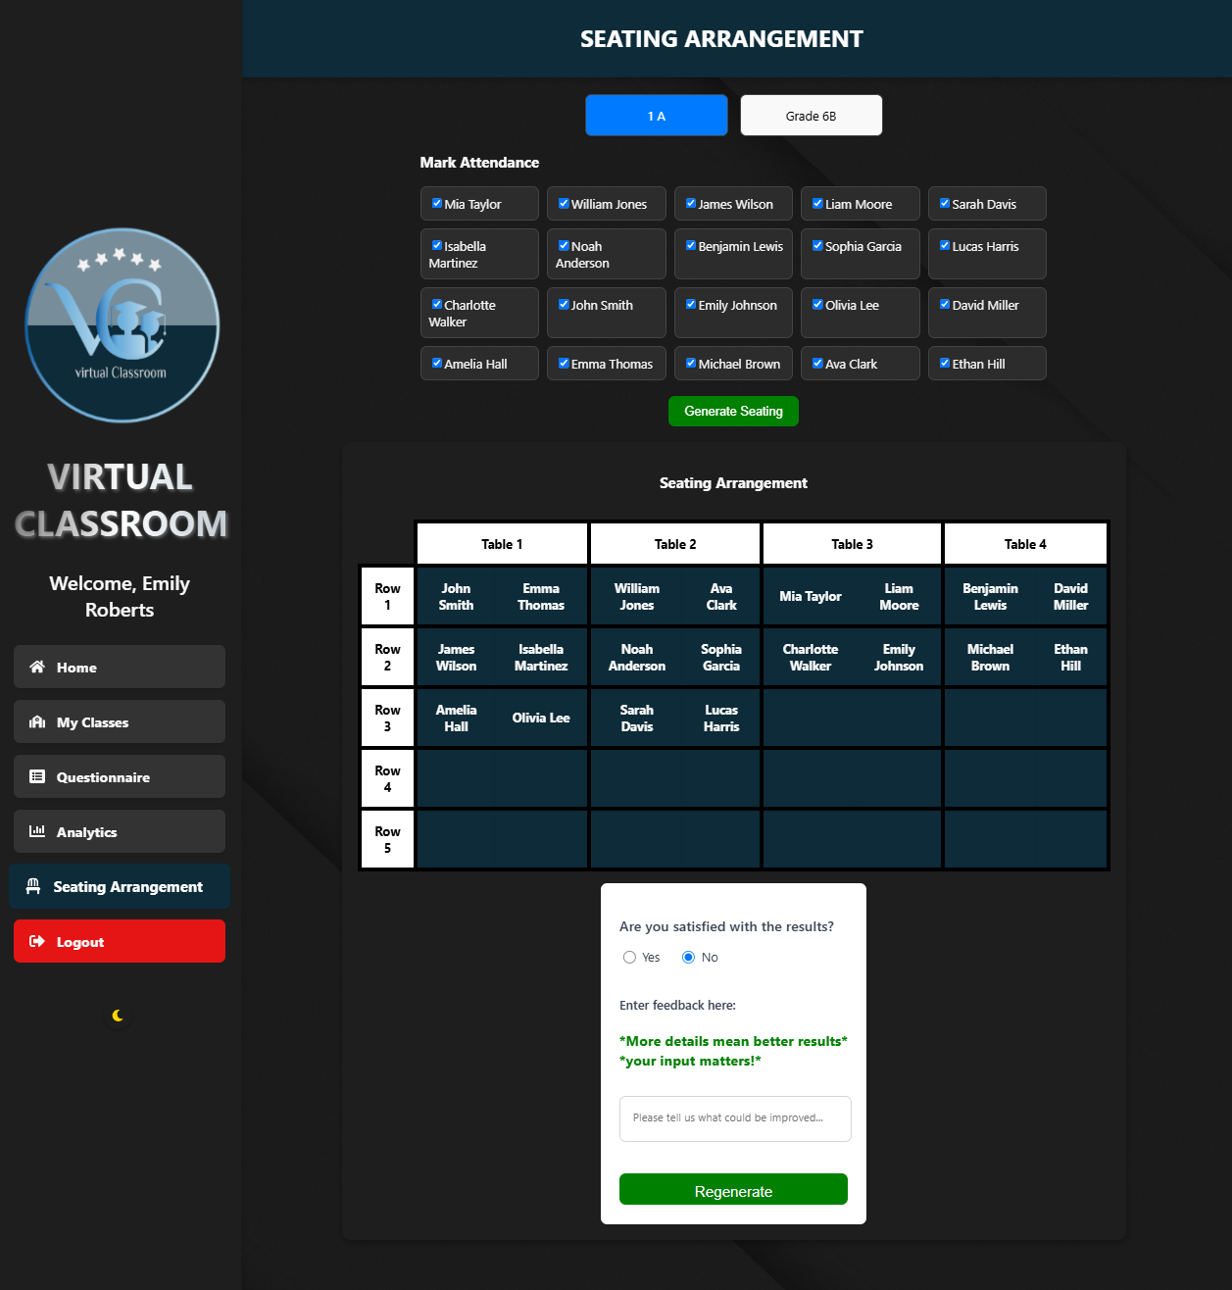

The **Seating Arrangement** Page is the core of the classroom management system, where teachers can organize student seating dynamically. Teachers start by selecting a class and marking the attendance of present students. The system then uses the classroom seating algorithm to generate an optimized arrangement based on collected student data, such as academic performance, behavior, and special needs. Once the seating is generated, it is displayed in an easy-to-read tabular format, categorized into tables and rows. Teachers can review the arrangement, provide feedback if needed, and regenerate the seating with adjustments, ensuring every student is seated in the most conducive environment for learning.

10-In Light Mode

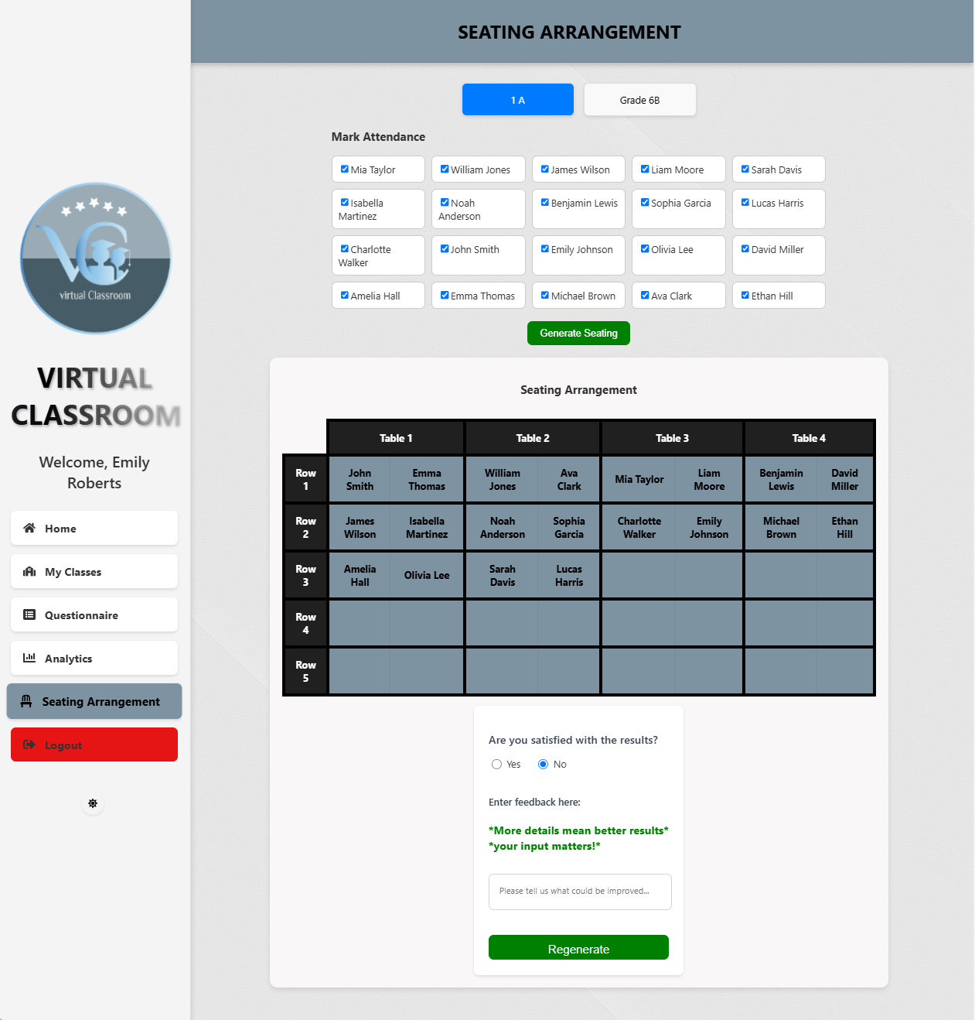



Software Engineering Department  
Braude College

Capstone Project Phase B – 61999

**Adaptive Student Arrangement System for Enhanced Learning**

**Maintenance Guide**

Advisor: Natali Levi

Students: Nabi Mari

Yoda Amer

Table Of Contents

**Table of Contents ................................................................................................................. 60  
Introduction .......................................................................................................................... 61  
1 System Architecture Overview ........................................................................................ 61**  
    1.1 System Components ..................................................................................................... 62  
    1.2 System Flow ................................................................................................................. 63  
**2 Software Dependencies ..................................................................................................... 64**    2.1 Backend Dependencies ................................................................................................ 64  
    2.2 Environment Management ........................................................................................... 65  
**3 Code Review ...................................................................................................................... 66**    3.1 App.js File .................................................................................................................... 66  
    3.2 index.js File .................................................................................................................. 66  
    3.3 Firebase Configuration Files ........................................................................................ 67  
        3.3.1 firebase.js ............................................................................................................... 67  
        3.3.2 firestore.rules ......................................................................................................... 67  
        3.3.3 firestore.indexes.json ............................................................................................. 68  
    3.4 Pages Folder ................................................................................................................. 68  
        3.4.1 Dashboard.js .......................................................................................................... 68  
        3.4.2 LoginPage.js .......................................................................................................... 68  
        3.4.3 RegisterPage.js ...................................................................................................... 69  
        3.4.4 MyClassesPage.js .................................................................................................. 69  
        3.4.5 ViewStudentsPage.js ............................................................................................. 69  
        3.4.6 ShowStudents.js .................................................................................................... 69  
        3.4.7 Questionnaire.js ..................................................................................................... 69  
        3.4.8 ShowQuesResults.js .............................................................................................. 70  
        3.4.9 Analytics.js ............................................................................................................ 70  
        3.4.10 GenerateSeating.js ............................................................................................... 70  
    3.5 Components Folder ...................................................................................................... 70  
        3.5.1 Layout.js ................................................................................................................ 70  
        3.5.2 PrivateRoute.js ...................................................................................................... 71  
        3.5.3 Sidebar.js ............................................................................................................... 71  
**4 Back-end Code ................................................................................................................... 71**  
    4.1 CSP Algorithm ............................................................................................................. 71  
    4.2 Data Processing Functions ........................................................................................... 72  
    4.3 Database Functions ...................................................................................................... 75  
        4.3.1 Functions in studentHandler.js .............................................................................. 75  
        4.3.2 Functions in classHandler.js ................................................................................. 76  
        4.3.3 Functions in seatingHandler.js .............................................................................. 77  
        4.3.4 Functions in teacherHandler.js .............................................................................. 77  
        4.3.5 Database Structure ................................................................................................. 78  
**5 Deployment ........................................................................................................................ 78**    5.1 Overview ...................................................................................................................... 78  
    5.2 Dashboard Deployment ................................................................................................ 79  
    5.3 The Control Panel ......................................................................................................... 79  
        5.3.1 Events .................................................................................................................... 80  
        5.3.2 Logs ....................................................................................................................... 80  
        5.3.3 Environment variables ........................................................................................... 80  
**External Links and Documentation .................................................................................... 81**

Introduction:

This Maintenance Guide provides detailed instructions and insights to help developers and administrators manage, update, and troubleshoot the Virtual Classroom System. The guide includes an overview of the system architecture, key components, and dependencies, along with code documentation for both the frontend and backend layers. Additionally, it outlines deployment strategies and critical maintenance workflows, ensuring the system operates seamlessly and meets evolving user requirements. This document serves as a comprehensive reference to maintain the system’s performance, security, and scalability.

1. **System Architecture Overview**

In this section, we outline the overall architecture of the system, explaining the structure, components, and workflow. The architecture is divided into logical layers, each playing a distinct role in the system's operation. Below is a detailed description.

* 1. **System Components**

The system follows a **client-server architecture** and comprises three main layers:



**1.1.1 Frontend Layer:**  
The frontend is built using **React.js** and manages all user interactions, including:

* **Pages:** Dashboard, Login, Register, Manage Students, Questionnaire, Analytics, and Generate Seating.
* **Components:** Reusable UI elements like Sidebar.js and PrivateRoute.js.
* **User Interaction:** Handles form submissions, visualizations, and real-time feedback from the user. It communicates with the backend through REST APIs to fetch data, manage users, and generate seating arrangements.
  + 1. **Backend Layer:**  
       The backend handles:
* **CSP Algorithm (via CSP.js):** Implements the core logic for generating classroom seating arrangements based on constraints like behavior, academic performance, and social preferences.
* **Services Folder:** Contains utility files (studentHandler.js, classHandler.js, analyticsHandler.js, etc.) to interact with Firebase and process teacher and student data.
* **Data Flow:** Ensures smooth communication between the frontend and database. Handles user authentication, data processing, and responses to API requests.
  + 1. **Database Layer:**  
       The system uses **Firebase Firestore** to store and retrieve:
* **Student and Teacher Data:** Including academic performance, behavior, preferences, and attendance.
* **Generated Seating Arrangements:** Stored for feedback and future analysis.
* **Authentication:** Managed using Firebase Authentication to secure access for teachers and administrators.

**1.2 System Flow**

The system operates through a defined workflow that integrates user input, backend processing, and real-time data storage. Here's the typical flow:

* + 1. **Authentication:**
  + Users (teachers) log in or register using secure credentials. The backend verifies the credentials using Firebase Authentication.
    1. **Dashboard Access:**
  + Upon successful login, teachers access the dashboard to manage classes, generate seating arrangements, and analyze results.
    1. **Data Collection:**
  + Teachers input or update student information through forms (e.g., academic performance, behavioral traits, social preferences). Data is validated and stored in Firestore.
    1. **Seating Generation (CSP Algorithm):**
  + The CSP.js file calculates optimal seating based on the student's priority scores and constraints.
  + Teachers can provide feedback to adjust seating for better classroom dynamics.
    1. **Feedback Loop:**
  + Teachers review and provide feedback on generated seating arrangements. Feedback is stored and used to refine future seating outputs.
    1. **Questionnaire and Analytics:**
  + Teachers fill out questionnaires and view analytics to evaluate classroom dynamics. Results are processed and visualized in the frontend.
    1. **Data Storage and Retrieval:**
  + All user inputs, generated data, and feedback are stored in Firebase Firestore for secure, real-time access.

**2 Software Dependencies**

The Classroom Seating Arrangement system relies on a well-defined set of software dependencies to ensure its functionality, performance, and maintainability. This section provides an overview of the key libraries and frameworks used across the frontend, backend, and algorithmic components of the system. Proper management and timely updates of these dependencies are essential for optimal system performance.

**2.1 Backend Dependencies**

The backend of the Classroom Seating Arrangement system is implemented using **Node.js** and Firebase services. These tools enable secure, efficient data management and robust real-time synchronization across the system. Below are the critical backend components and their purposes:

* + 1. **Node.js:**  
       Serves as the foundation for backend logic, providing event-driven, non-blocking I/O capabilities. It ensures scalable and efficient processing for the REST API and algorithmic computations.
    2. **Firebase Firestore:**  
       Firestore is the cloud-based NoSQL database used to store and manage data. It supports real-time updates, ensuring that changes to class, student, or seating data are immediately reflected in the system.
    3. **Firebase Authentication:**  
       This service secures user authentication, ensuring only verified teachers and users can access specific functionalities like managing classes or generating seating arrangements.
    4. **Services Folder:**  
       A collection of modular backend services that handle distinct system operations:
* **analyticsHandler.js:** Aggregates and analyzes questionnaire responses to provide actionable insights for teachers.
* **apiService.js:** Facilitates communication with optional external APIs for enhanced features.
* **authHandler.js:** Manages user authentication tasks, including login and registration.
* **classHandler.js:** Handles class-specific operations, such as retrieving or updating class data.
* **seatingHandler.js:** Implements logic to create and save optimized seating matrices.
* **studentHandler.js:** Manages CRUD operations for student data.
* **teacherHandler.js:** Manages teacher profiles and their respective class data.
  + 1. **Algorithms (CSP):**  
       The CSP.js file contains the core **Constraint Satisfaction Problem** algorithm used for generating seating arrangements. This algorithm uses student data, including academic performance, behavioral traits, social preferences, and special needs, to optimize the seating plan based on defined constraints.

**2.2 Environment Management**

The system operates in a **Node.js environment** to ensure compatibility with its dependencies. Dependency management is achieved using npm (Node Package Manager), and the environment setup is streamlined using a package.json file.

**Steps to Install Dependencies:**

1. Clone the repository.
2. Run npm install to install all necessary dependencies as specified in the package.json file.

**Key Tools for Development and Deployment:**

* **Vercel:** For hosting the frontend, enabling a seamless deployment experience with automatic builds and version control.
* **Firebase CLI:** Used for deploying backend functionalities and managing Firebase services like Firestore and Authentication.

**3. Code Review**

This section provides a comprehensive review of the key code files in the project, detailing their structure, functionality, and any considerations for future maintenance or enhancements.

**3.1 App.js File**

* **Purpose**: Serves as the entry point for routing and layout management in the React application.
* **Key Features**:
* Integrates React Router for dynamic navigation.
* Manages authentication state via AuthContext.
* Implements a dark/light mode toggle with persistent state using localStorage.
* Uses PrivateRoute to secure routes accessible only to authenticated users.
* **Maintenance Tips:**
* Ensure all routes are updated if new features are added.
* Regularly check compatibility of third-party libraries (e.g., React Router).

**3.2 index.js File**

* **Purpose**: The main entry point for rendering the React application into the DOM.
* **Key Features**:
* Wraps the application with AuthContext and theme providers.
* Mounts the application on the root DOM node.
* **Maintenance Tips**:
* Keep React and ReactDOM versions aligned for compatibility.
* Ensure proper cleanup of context providers if modifications are made.

**3.3 Firebase Configuration Files**

**3.3.1 firebase.js**

* **Purpose**: Configures and initializes Firebase services for authentication and Firestore database.
* **Key Features**:
* Contains Firebase API keys and project identifiers.
* Initializes Firebase services such as Firestore and Authentication.
* **Maintenance Tips**:
* Keep API keys secure and avoid exposing them in the client-side code.
* Rotate keys periodically to enhance security.

**3.3.2 firestore.rules**

* **Purpose**: Defines access rules for Firestore to ensure secure data handling.
* **Key Features**:
* Restricts read and write permissions based on authentication state.
* **Maintenance Tips**:
* Regularly audit rules to ensure compliance with new features.
* Test rule changes in a staging environment before deploying to production.

**3.3.3 firestore.indexes.json**

* **Purpose**: Specifies indexing for Firestore queries to optimize performance.
* **Key Features**:
* Includes compound indexes for frequently queried fields.
* **Maintenance Tips**:
* Update indexes whenever new queries are introduced.
* Monitor Firestore usage to identify and optimize slow queries.

**3.4 Pages Folder**

**3.4.1 Dashboard.js**

* **Purpose**: Provides an overview of the teacher’s activity, linking to key features like analytics and seating.
* **Maintenance Tips**:
* Keep navigation links updated as new features are added.
* Test responsiveness across various screen sizes.

**3.4.2 LoginPage.js**

* **Purpose**: Handles user authentication through Firebase.
* **Maintenance Tips**:
* Add support for multi-factor authentication if required.
* Regularly test the password reset flow.

**3.4.3 RegisterPage.js**

* **Purpose**: Allows teachers to register and store their data in Firestore.
* **Maintenance Tips**:
* Validate email domains and ensure unique registrations.
* Test error messages for clarity and relevance.

**3.4.4 MyClassesPage.js**

* **Purpose**: Displays all classes managed by the teacher and allows navigation to detailed views.
* **Maintenance Tips**:
* Ensure data consistency when adding or removing classes.
* Optimize Firestore queries for large datasets.

**3.4.5 ViewStudentsPage.js**

* **Purpose**: Provides detailed management for students in a specific class.
* **Maintenance Tips**:
* Validate student data before submission.
* Ensure smooth handling of edge cases like empty student lists.

**3.4.6 ShowStudents.js**

* **Purpose**: Displays a list of students and enables searching and questionnaire actions.
* **Maintenance Tips**:
* Optimize search functionality for large datasets.
* Regularly test the filtering and sorting features.

**3.4.7 Questionnaire.js**

* **Purpose**: Allows teachers to complete a detailed questionnaire for each student.
* **Maintenance Tips**:
* Validate form inputs to ensure accurate data submission.
* Test conditional rendering of questionnaire sections.

**3.4.8 ShowQuesResults.js**

* **Purpose**: Displays and edits previously submitted questionnaire responses.
* **Maintenance Tips**:
* Ensure data integrity when editing responses.
* Test the navigation back to the student list.

**3.4.9 Analytics.js**

* **Purpose**: Provides graphical analytics for class data using Chart.js.
* **Maintenance Tips**:
* Test the accuracy of data visualizations.
* Update charts to include new metrics if introduced.

**3.4.10 GenerateSeating.js**

* **Purpose**: Generates seating arrangements using the CSP.js algorithm.
* **Maintenance Tips**:
* Test the algorithm’s handling of edge cases like absent students.
* Optimize the algorithm for large class sizes.

**3.5 Components Folder**

**3.5.1 Layout.js**

* **Purpose**: Manages the page layout, including dark/light mode styling.
* **Maintenance Tips**:
* Ensure consistent styling across different themes.
* Test responsiveness for mobile devices.

**3.5.2 PrivateRoute.js**

* **Purpose**: Protects routes by requiring user authentication.
* **Maintenance Tips**:
* Test route protection for edge cases like expired sessions.
* Update redirection logic as new routes is added.

**3.5.3 Sidebar.js**

* **Purpose**: Implements a navigational sidebar with theme toggling.
* **Maintenance Tips**:
* Test sidebar behavior for different screen resolutions.
* Regularly review navigation links for relevance.

**4. Back-end Code**

This section provides a comprehensive overview of the back-end components of the system, explaining their purpose, functionality, and how they interact with the front-end and database. It delves into the system's core logic, services, data processing functions, and database management.

**4.1 CSP Algorithm**

The Constraint Satisfaction Problem (CSP) algorithm forms the backbone of the classroom seating optimization logic. It is implemented in the CSP.js file and executes the following steps:

* **Initialization:**  
  The constructor initializes essential variables, including the number of rows, seats per row, and student data. It creates an empty seating matrix and prepares configurations for applying constraints like behavioral rules and special needs prioritization.
* **Preprocessing:**  
  The preprocessStudents() function evaluates each student’s attributes—academic performance, behavior, social preferences, and special needs. These attributes are assigned weights based on importance, and a priority score is computed. For special needs students, the priority score is increased to ensure their seating placement adheres to their specific requirements.
* **Seat Assignment:**  
  The algorithm utilizes sorting, constraint validation, and backtracking to assign seats while satisfying all rules. Special needs students are prioritized in the first rows, ensuring accessibility and support.
* **Output:**  
  The algorithm generates an X*Y matrix representing the optimized seating arrangement. This matrix is returned for rendering in the front-end and for saving in the database.

**4.2 Data Processing Functions**

This section explains the functions responsible for handling, processing, and managing data within the system. These functions are crucial for ensuring the data's integrity and usability before further operations or storage. Below is a breakdown of the key data processing functions found in the backend services and their purposes:

**4.2.1 Functions in CSP.js**

1. **preprocessStudents()**

**Purpose**: Processes student data to calculate their priority scores based on responses and constraints.

**Details**:

Computes scores for factors such as academic level, behavior, social preferences, and special needs.

Adjusts scores for special needs to prioritize these students during seating arrangement generation.

Sorts the student list by priority score for optimized processing.

1. **createSeatingMatrix()**

**Purpose**: Converts the sorted student list into a seating matrix.

**Details**:

Iterates through rows and columns of the classroom layout.

Places students in sequence according to their priority scores, ensuring no duplicates.

1. **placeStudentAnywhere(student)**

**Purpose**: Places a student in the first available seat as a fallback.

**Details**:

Checks every row and column for an empty seat.

Validates placement using constraints to ensure seating rules are not violated.

1. **distributeRemainingStudents()**

**Purpose**: Ensures all students are seated after the initial arrangement.

* + **Details**:

Identifies unseated students from the sorted list.

Attempts to place each unseated student in any valid seat.

1. **RegenerateSeating(studentMatrix, previousFeedback)**

**Purpose**: Adjusts an existing seating arrangement based on teacher feedback.

**Details**:

Uses GPT-4 API to suggest a refined seating arrangement.

Replaces the current matrix with the updated arrangement.

**Functions in studentHandler.js**

1. **fetchStudentDataWithResponses(presentStudents)**

**Purpose**: Retrieves detailed data for students marked as present.

**Details**:

Fetches responses and other relevant attributes for each student.

Ensures that all required data is available for further processing.

1. **updateStudentMainInfo(studentId, updatedData)**

**Purpose**: Updates the main attributes of a student.

**Details**:

Updates fields such as academic level, behavior, and special needs in the database.

**Functions in seatingHandler.js**

1. **saveSeatingArrangement(classId, seatingMatrix)**

**Purpose**: Stores the generated seating matrix in the database.

**Details**:

Associates the matrix with a specific class ID for future retrieval.

1. **retrieveSeatingArrangement(classId)**

**Purpose**: Fetches a previously saved seating arrangement for a class.

**Details**:

Retrieves the seating matrix to display or adjust based on new feedback.

**4.3 Database Functions**

This section focuses on the functions within the back-end system responsible for interacting with the Firebase Firestore database. These functions facilitate storing, retrieving, and managing data related to students, teachers, classes, and seating arrangements.

**4.3.1 Functions in studentHandler.js**

1. **addStudentToClass(studentData)**

**Purpose**: Adds a new student to a specific class in the database.

**Details**:

Creates a new document in the students collection under the respective class.

Stores attributes such as name, age, academic level, behavior, special needs, and associated class ID.

Ensures data consistency for subsequent processing.

1. **updateStudentMainInfo(studentId, updatedData)**

**Purpose**: Updates specific details of a student in the database.

**Details**:

Finds the student document by its unique ID.

Updates fields like behavior, academic level, or special needs, reflecting the latest information.

1. **getStudentsByClassID(classId)**

**Purpose**: Retrieves all students associated with a specific class.

**Details**:

Queries the students collection for documents linked to the given classId.

Returns a list of student documents, including their details and responses.

**4.3.2 Functions in classHandler.js**

1. **createClass(name, teacherId)**

**Purpose**: Creates a new class associated with a teacher.

**Details**:

Adds a new document in the classes collection.

Stores the class name, teacher ID, and metadata like creation date.

1. **fetchClassDetails(classId)**

**Purpose**: Retrieves details about a specific class.

**Details**:

Queries the classes collection using the class ID.

Returns metadata and references to students or seating arrangements.

**4.3.3 Functions in seatingHandler.js**

1. **saveSeatingArrangement(classId, seatingMatrix)**

**Purpose**: Stores a generated seating arrangement in the database.

**Details**:

Saves the seating matrix under the respective class document.

Allows retrieval for future adjustments or teacher reviews.

1. **retrieveSeatingArrangement(classId)**

**Purpose**: Fetches a previously saved seating arrangement.

**Details**:

Queries the database for the seating arrangement linked to the specified class.

Returns the matrix for display or further updates.

**4.3.4 Functions in teacherHandler.js**

1. **getTeacherClasses(teacherId)**

**Purpose**: Retrieves all classes created by a specific teacher.

**Details**:

Queries the classes collection for documents associated with the teacher’s ID.

Provides a list of class metadata for managing multiple groups.

**4.3.5 Database Structure**

- **Collections**:

* **teachers**: Stores teacher profiles, including their ID, name, and metadata such as registration dates and associated classes.
* **classes**: Contains documents for each class. Each document includes the class name, teacher ID, student references, and associated metadata.
* **students**: Stores detailed student information, such as academic performance, behavioral traits, and any responses to questionnaires.
* **seating_arrangements**: Tracks generated seating matrices. Each document links to a specific class and holds the arrangement as an X*Y matrix.
* **config**: Stores sensitive or dynamic configuration settings, such as:
  + API keys for external services (e.g., GPT or analytics tools).
  + System-wide settings for behavior thresholds or scoring weights.
* **Data Relationships**:
* **Teachers** manage multiple classes, and their IDs serve as references in the classes collection.
* **Classes** have a one-to-many relationship with students and a one-to-one relationship with seating_arrangements.
* **Config** provides centralized access to settings used across the system, ensuring adaptability without modifying the core code.

**5. Deployment**

**5.1 Overview**

The deployment process for the Virtual Classroom project utilizes Vercel for hosting the React frontend and Firebase for backend services, including authentication and Firestore database operations. This combination ensures scalability, real-time data synchronization, and seamless performance across all devices.

**5.2 Dashboard Deployment**

The main dashboard is deployed using Vercel. It serves as the central hub for teachers to manage classes, students, and analytics. Firebase provides real-time backend integration, ensuring data consistency.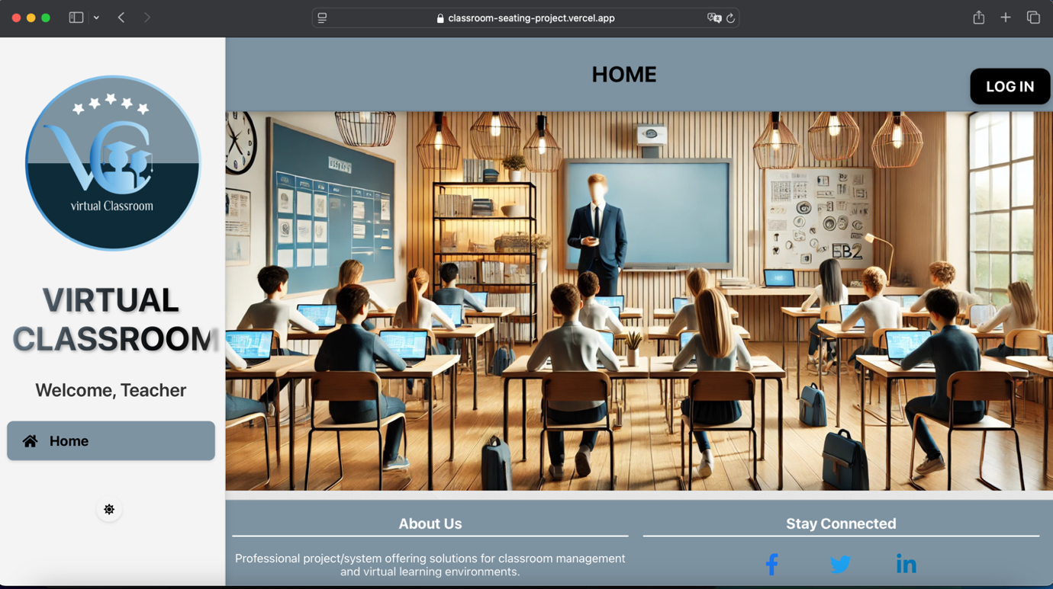

**5.3 The Control Panel**

Both Vercel and Firebase offer control panels to monitor, manage, and debug the application. The following features are particularly useful:

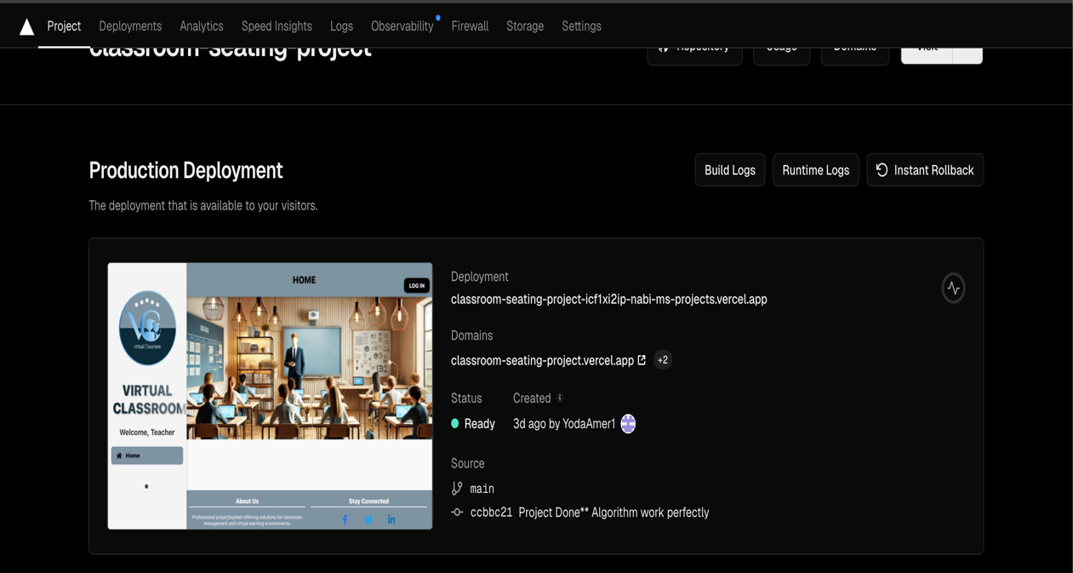**5.3.1 Deployment Events** Tracks build and deployment history on Vercel. Errors or warnings encountered during builds can be identified and addressed here.

Vercel deployment history showing a successful build.

**5.3.2 Logs**

Provides access to logs from Firebase and Vercel, detailing serverless function calls and database activity. Logs help in debugging and improving performance.

**5.3.3 Environment Variables**

Manages sensitive keys and configurations, such as the ChatGPT API key. These keys are securely stored in Firestore under the "config" collection for seamless integration with the backend.

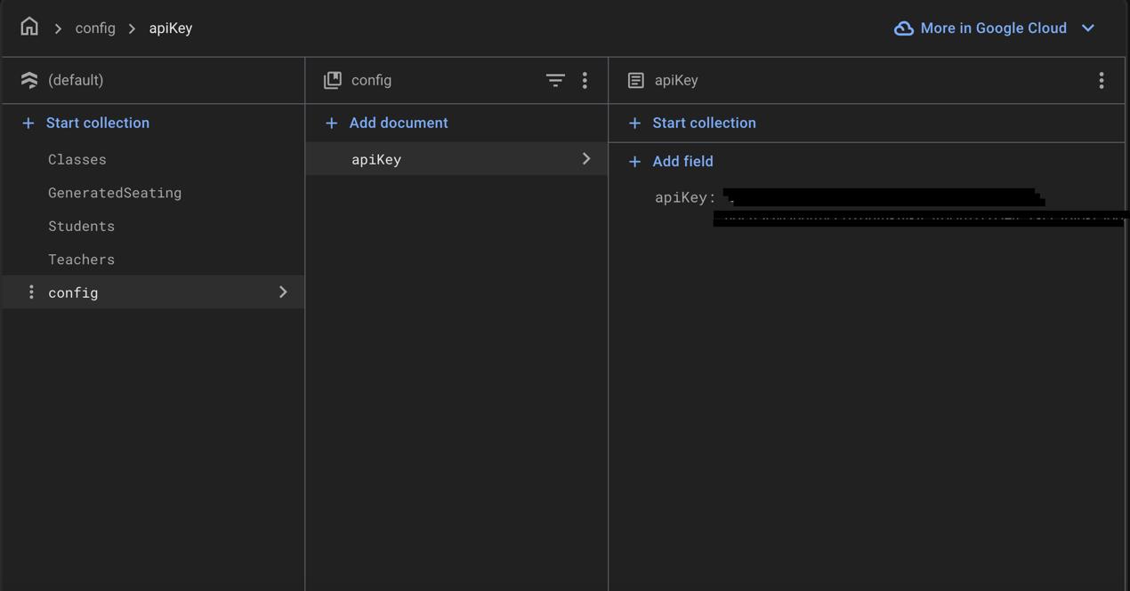

**External Links and Documentation:**

* **Vercel Documentation**: <https://vercel.com/docs>
* **Firebase Documentation**: <https://firebase.google.com/docs>
* **React Documentation**: <https://reactjs.org/docs>